### Managing Incoming and Outgoing Traffic to and from Istio Cluster

Lets see how to enable the incoming and outgoing connection to and from that Istio cluster for the external entities. That's where I'm going to explain first the ingress and then erase configurations. Let's start with the ingress. If you don't mind my hand-drawn diagram it should at least give you a good understanding of the ingress traffic management.

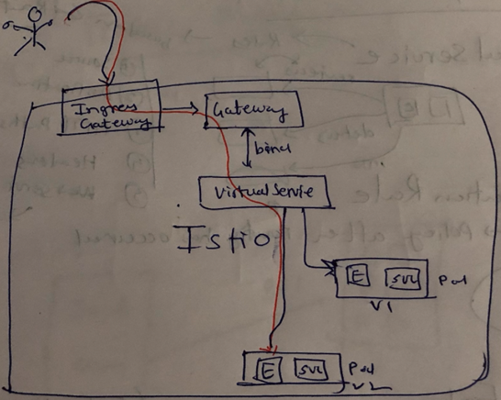

So what do you see in this diagram. Is this your cluster. And let's assume a user outside wants to get an access to a service inside that Istio cluster. So the first thing that you would need is the Ingress Gateway. That's what you see on the top left corner of the ingress box and ingress Gateway has already been provisioned when we set up Istio, in addition to this what are you going to need in order to enable this increased traffic is the Ingress Gateway. We now get it similar to the ingress controllers in K8s but the difference here is gateways in Istio do not do the HTTP routing. HTTP routing is done by the virtual service, in case of ingress controllers in K8s. It is Layer 7 application level load balancer. So it basically does routing and then forwarding to the services as well. And in case of Istio in addition to the Gateway you're going to need the Virtual Service where you define the rules and you define that hey if a request comes with this hostname with this route. It should go to a particular service and that is what is going to route your traffic to that service so you're going to need three things – Ingress gateway which has already been provisioned. The gateway which is like a load balancer like Ingress Controller in K8s. And in addition to that you're going to need a virtual service and virtual service gets bound to that gateway. So that's the configuration that I want to show you and in the next video how do you actually enable the ingress traffic.

|  |  |
| --- | --- |
|  | After which we'll move on to the outgoing connections that is egress traffic. Now in this scenario a service inside Istio cluster wants to talk to an external service and the external service can be let's say a Maps API which is sitting outside. Or it could be a video API service which your service is going to need to call. Now by default the outgoing connections are blocked for Istio service smash. So there is no outgoing connection by default you have to enable that through this egress gateway and then there is another configuration called as service entry. |

So egress gateway has been provisioned with your Istio cluster just like ingress gateway it is already running. In addition to this just like Gateway and Virtual Service, you are going to configure the service entry and Virtual Service. Virtual service will be there which will do the routing. That is what is going to define that, If you want to access to Google.com which is outside our maps.api.com or in our example it's going to be <http://bin.com>.

It is going to create a virtual service entry for that. And for that there will be a service entry and the service will route anything which goes to that host through that gate egress Service entry and egress gateway. That is how your service will be able to communicate to the outside world. Now we will see the incoming traffic ingress gateways configuration and followed by the egress outgoing configurations. And before we get started here's a configuration for ingress and egress. So if you list the pods in Istio System namespace you'll find egress and ingress running as part of those pods and if you use –o wide it will also show you which nodes it is running on for example in my environment my egress is running on 04 versus ingress is running on 02 as a system.

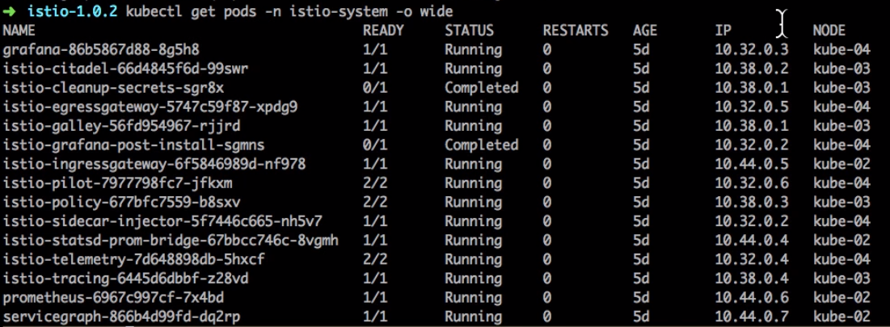

### Configure incoming connections to Istio Cluster with Gateway

<https://istio.io/docs/tasks/traffic-management/ingress/#configuring-ingress-using-an-istio-gateway>

Control Ingress Traffic

In a Kubernetes environment, the [Kubernetes Ingress Resource](https://kubernetes.io/docs/concepts/services-networking/ingress/) is used to specify services that should be exposed outside the cluster. In an Istio service mesh, a better approach (which also works in both Kubernetes and other environments) is to use a different configuration model, namely [Istio Gateway](https://istio.io/docs/reference/config/istio.networking.v1alpha3/#Gateway). A Gateway allows Istio features such as monitoring and route rules to be applied to traffic entering the cluster.

This task describes how to configure Istio to expose a service outside of the service mesh using an Istio Gateway.

**Before you begin**

Setup Istio by following the instructions in the [Installation guide](https://istio.io/docs/setup/).

Make sure your current directory is the istio directory.

Start the [httpbin](https://github.com/istio/istio/tree/release-1.0/samples/httpbin) sample, which will be used as the destination service to be exposed externally.

If you have enabled [automatic sidecar injection](https://istio.io/docs/setup/kubernetes/sidecar-injection/#automatic-sidecar-injection), deploy the httpbin service:

$ kubectl apply -f [samples/httpbin/httpbin.yaml](https://raw.githubusercontent.com/istio/istio/release-1.0/samples/httpbin/httpbin.yaml)

Otherwise, you have to manually inject the sidecar before deploying the httpbin application:

$ kubectl apply -f <(istioctl kube-inject -f [samples/httpbin/httpbin.yaml](https://raw.githubusercontent.com/istio/istio/release-1.0/samples/httpbin/httpbin.yaml))

Determine the ingress IP and ports as described in the following subsection.

Determining the ingress IP and ports

Execute the following command to determine if your Kubernetes cluster is running in an environment that supports external load balancers:

$ kubectl get svc istio-ingressgateway -n istio-system

NAME TYPE CLUSTER-IP EXTERNAL-IP PORT(S) AGE

istio-ingressgateway LoadBalancer 172.21.109.129 130.211.10.121 80:31380/TCP,443:31390/TCP,31400:31400/TCP 17h

If the EXTERNAL-IP value is set, your environment has an external load balancer that you can use for the ingress gateway. If the EXTERNAL-IP value is <none> (or perpetually <pending>), your environment does not provide an external load balancer for the ingress gateway. In this case, you can access the gateway using the service’s [node port](https://kubernetes.io/docs/concepts/services-networking/service/#nodeport).

Depending on your environment, follow the instructions in one of the following **mutually exclusive** subsections.

Determining the ingress IP and ports when using an external load balancer

Follow these instructions if you have determined that your environment **does have** an external load balancer.

Set the ingress IP and ports:

$ export INGRESS_HOST=$(kubectl -n istio-system get service istio-ingressgateway -o jsonpath='{.status.loadBalancer.ingress[0].ip}')

$ export INGRESS_PORT=$(kubectl -n istio-system get service istio-ingressgateway -o jsonpath='{.spec.ports[?(@.name=="http2")].port}')

$ export SECURE_INGRESS_PORT=$(kubectl -n istio-system get service istio-ingressgateway -o jsonpath='{.spec.ports[?(@.name=="https")].port}')

Note that in certain environments, the load balancer may be exposed using a host name, instead of an IP address. In this case, the EXTERNAL-IP value in the output from the command in the previous section will not be an IP address, but rather a host name, and the above command will have failed to set the INGRESS_HOST environment variable. In this case, use the following command to correct the INGRESS_HOST value:

$ export INGRESS_HOST=$(kubectl -n istio-system get service istio-ingressgateway -o jsonpath='{.status.loadBalancer.ingress[0].hostname}')

Determining the ingress IP and ports when using a node port

Follow these instructions if you have determined that your environment **does not have** an external load balancer.

Set the ingress ports:

$ export INGRESS_PORT=$(kubectl -n istio-system get service istio-ingressgateway -o jsonpath='{.spec.ports[?(@.name=="http2")].nodePort}')

$ export SECURE_INGRESS_PORT=$(kubectl -n istio-system get service istio-ingressgateway -o jsonpath='{.spec.ports[?(@.name=="https")].nodePort}')

Setting the ingress IP depends on the cluster provider:

GKE:

$ export INGRESS_HOST=<workerNodeAddress>

You need to create firewall rules to allow the TCP traffic to the ingressgateway service’s ports. Run the following commands to allow the traffic for the HTTP port, the secure port (HTTPS) or both:

$ gcloud compute firewall-rules create allow-gateway-http --allow tcp:$INGRESS_PORT

$ gcloud compute firewall-rules create allow-gateway-https --allow tcp:$SECURE_INGRESS_PORT

Minikube:

$ export INGRESS_HOST=$(minikube ip)

Other environments (e.g., IBM Cloud Private etc):

$ export INGRESS_HOST=$(kubectl get po -l istio=ingressgateway -n istio-system -o 'jsonpath={.items[0].status.hostIP}')

Configuring ingress using an Istio Gateway

An ingress [Gateway](https://istio.io/docs/reference/config/istio.networking.v1alpha3/#Gateway) describes a load balancer operating at the edge of the mesh that receives incoming HTTP/TCP connections. It configures exposed ports, protocols, etc. but, unlike [Kubernetes Ingress Resources](https://kubernetes.io/docs/concepts/services-networking/ingress/), does not include any traffic routing configuration. Traffic routing for ingress traffic is instead configured using Istio routing rules, exactly in the same was as for internal service requests.

Let’s see how you can configure a Gateway on port 80 for HTTP traffic.

1. Create an Istio Gateway:

cat <<EOF | kubectl apply -f -

apiVersion: networking.istio.io/v1alpha3

kind: Gateway

metadata:

name: httpbin-gateway

spec:

selector:

istio: ingressgateway # use Istio default gateway implementation

servers:

- port:

number: 80

name: http

protocol: HTTP

hosts:

- "httpbin.example.com"

EOF

1. Configure routes for traffic entering via the Gateway:

cat <<EOF | kubectl apply -f -

apiVersion: networking.istio.io/v1alpha3

kind: VirtualService

metadata:

name: httpbin

spec:

hosts:

- "httpbin.example.com"

gateways:

- httpbin-gateway

http:

- match:

- uri:

prefix: /status

- uri:

prefix: /delay

route:

- destination:

port:

number: 8000

host: httpbin

EOF

You have now created a [virtual service](https://istio.io/docs/reference/config/istio.networking.v1alpha3/#VirtualService) configuration for the httpbin service containing two route rules that allow traffic for paths /status and /delay.

The [gateways](https://istio.io/docs/reference/config/istio.networking.v1alpha3/#VirtualService-gateways) list specifies that only requests through your httpbin-gateway are allowed. All other external requests will be rejected with a 404 response.

Note that in this configuration, internal requests from other services in the mesh are not subject to these rules but instead will default to round-robin routing. To apply these or other rules to internal calls, you can add the special value mesh to the list of gateways.

1. Access the httpbin service using curl:

$ curl -I -HHost:httpbin.example.com http://$INGRESS_HOST:$INGRESS_PORT/status/200

*HTTP/1.1 200 OK*

*server: envoy*

*date: Mon, 29 Jan 2018 04:45:49 GMT*

*content-type: text/html; charset=utf-8*

*access-control-allow-origin: \**

*access-control-allow-credentials: true*

*content-length: 0*

*x-envoy-upstream-service-time: 48*

Note that you use the -H flag to set the Host HTTP Header to “httpbin.example.com”. This is needed because your ingress Gateway is configured to handle “httpbin.example.com”, but in your test environment you have no DNS binding for that host and are simply sending your request to the ingress IP.

1. Access any other URL that has not been explicitly exposed. You should see an HTTP 404 error:

$ curl -I -HHost:httpbin.example.com http://$INGRESS_HOST:$INGRESS_PORT/headers

*HTTP/1.1 404 Not Found*

*date: Mon, 29 Jan 2018 04:45:49 GMT*

*server: envoy*

*content-length: 0*

**Accessing ingress services using a browser**

Entering the httpbin service URL in a browser won’t work because you can’t tell the browser to pretend to be accessing httpbin.example.com like with curl. In a real world situation, this is not a problem because because you configure the requested host properly and DNS resolvable. Thus, you use the host’s domain name in the URL, for example, <https://httpbin.example.com/status/200>.

To work around this problem for simple tests and demos, use a wildcard * value for the host in the Gateway and VirutualService configurations. For example, if you change your ingress configuration to the following:

cat <<EOF | kubectl apply -f -

apiVersion: networking.istio.io/v1alpha3

kind: Gateway

metadata:

name: httpbin-gateway

spec:

selector:

istio: ingressgateway # use Istio default gateway implementation

servers:

- port:

number: 80

name: http

protocol: HTTP

hosts:

- "*"

---

apiVersion: networking.istio.io/v1alpha3

kind: VirtualService

metadata:

name: httpbin

spec:

hosts:

- "*"

gateways:

- httpbin-gateway

http:

- match:

- uri:

prefix: /headers

route:

- destination:

port:

number: 8000

host: httpbin

EOF

You can then use $INGRESS_HOST:$INGRESS_PORT (e.g., 192.168.99.100:31380) in the browser URL. For example, http://192.168.99.100:31380/headers should display the request headers sent by your browser.

Understanding what happened

The Gateway configuration resources allow external traffic to enter the Istio service mesh and make the traffic management and policy features of Istio available for edge services.

In the preceding steps, you created a service inside the service mesh and exposed an HTTP endpoint of the service to external traffic.

Cleanup

Delete the Gateway configuration, the VirtualService and the secret, and shutdown the [httpbin](https://github.com/istio/istio/tree/release-1.0/samples/httpbin) service:

$ kubectl delete gateway httpbin-gateway

$ kubectl delete virtualservice httpbin

$ kubectl delete --ignore-not-found=true -f [samples/httpbin/httpbin.yaml](https://raw.githubusercontent.com/istio/istio/release-1.0/samples/httpbin/httpbin.yaml)

### TroubleShooting Ingress Gateway

In the previous video I showed you how to set up the gateway, the virtual services and we started accessing that allocation which didn't work.

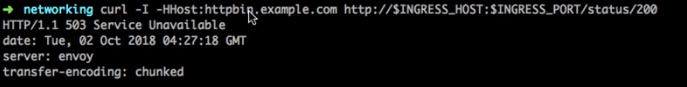

Now in order for this to work which actually says that service unavailable. So the way I started debugging this was to start checking the pods which are running for the ingress service which is in this Istio system. This is the service, this is the list of pods rather.

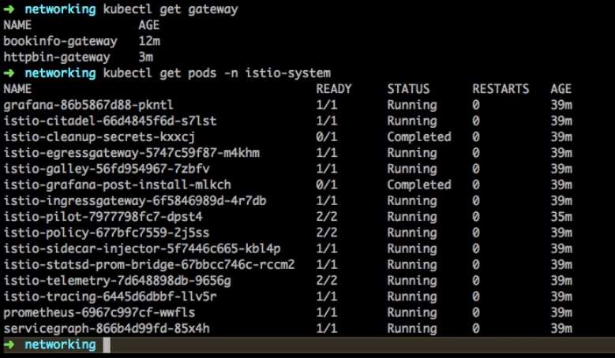

And I have a pod for the ingress gateway. Now in order to see what is happening I could actually go and look at the logs as well. So that's what I did using kubectl get logs command. Now in order for this to work you need to know a little bit of kubernetes as well, and how K8s operates. And when I started to look at the logs, I noticed that it's sending the request but it is getting the error.

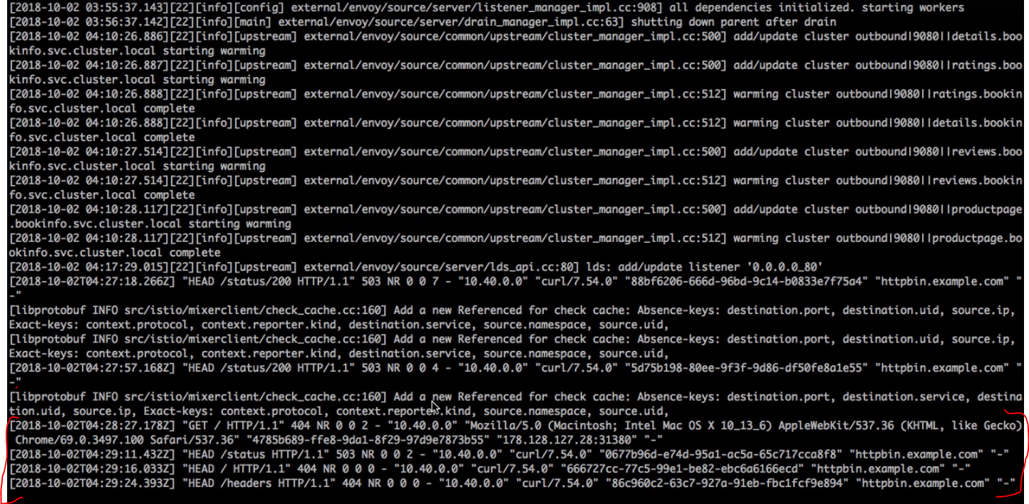

So the most likely reason for this is the actual pod of the application or this is running behind this does not exist so that's why it shows the error status which is 404, 404 is not found basically. I needed to ensure that the actual service behind it is also running. So I scrolled up and in the documentation, it talks about starting. They should have be been off. So they're just trying to send the request for a httpbin but service does not exist, so when I scrolled up it had a clear instruction about before you begin you should start the httpbin as an application or service.

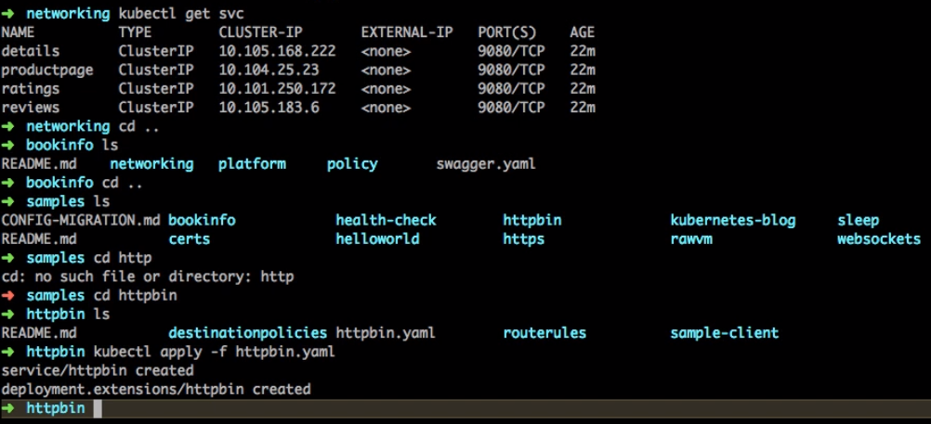

and that's what I did to fix this issue. So I went back to the samples directory, inside the samples again there is this httpbin and I had to apply the YAML to create this service and that deployment for this particular application. Again this is a additional application to the bookinfo, so now I see the service for httpbin and I should have a deployment for that as well and that should just make it work. In the pods as well, I see the applications that I have running here and if I run the curl command, this time it works with that hyphen status.

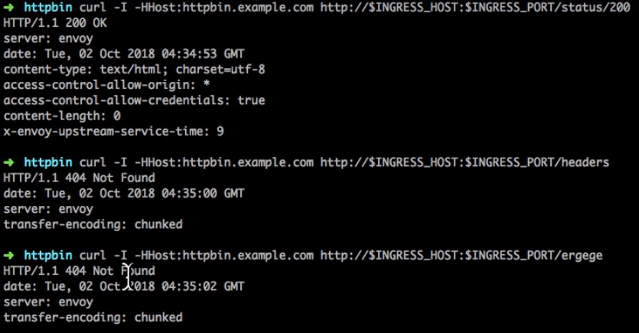

Earlier there was a error. Now it works. And for anything else it does not. So if I use anything apart from the requested resources, it does not allow me to run that. Right know, how to access it from outside? That's another question. So this was the goal but to access it from outside we have to expose it somewhat out of the service. This is the ingress and egress gateway. So either you need a DNS or you need to take either of these steps

* one step is you can actually configure an alias. That's what I'm going to add in DC host. And so that it becomes like a automatic resolution local resolution or
* you can just change the host field to star instead of that there should be been. Which is what it is listening for in the headers. If it change it to Star It means that any host and it is going to be doing the routing based on the /<routes> in this case maybe little /headers. And

That's another approach that you could possibly take. Now I wanted to find out the ingress host and the port. So I wanted to set that up in my previous video, as a environment variable. So I'm going to find that host and port and then added an entry to my /etc/host and this is it I'm going to add the hostname and the IP address that it should point to. This is equivalent to setting up a DNS server. It will automatically do the name resolution locally and I should be able to access it with the hostname and if I try that httpbin.example.com/headers.

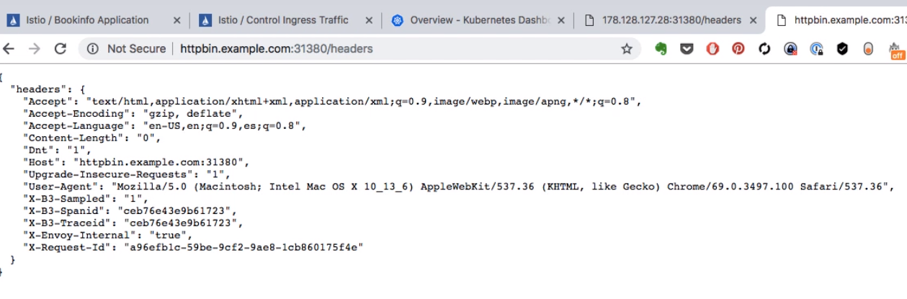

|  |  |
| --- | --- |
|  | This is the only path available now because that's the service has changed a bit and the port number or if you have the service you could use status and two hundred which show some page. This shows me the headers that I'm sending to this application. So this is one way of accessing it. The second way is of course you set up or you know change the services, the gateway and virtual services such that instead of the hostname, it accepts star which means any hostname.  And if you observe the path, the path has changed to /header actually did this first and then started using DNS locally. So there is a little bit of a change in the sequence. |

|  |  |
| --- | --- |
|  | So if you don't see /headers in the first time, you apply this service, you apply the change and then you try and access it. So if I go and access my IP address colon the port that is Ingress port slash the path – the route, in this case the route is headers. So if I access it using the host and the port, host and port doesn't work because I have to provide the pod This is the path based routing, so /headers gives me the exact same output so I could use either either the etc host entry or you could directly use the host and port configuration here as well. |

The easier way is to use the star and use the host IP address and the port that is. Now this is how you can access this application from outside. And this was just a sample httpbin application. If you want to access your own application. that is the bookinfo, we have the routes created for it or if not we would have to create the routes and look at the ingress gateways configuration – there is the gateway and virtual services configuration in order for it to be available. So this is what I'm going to use to confirm that is running. All of these rules were created earlier, in the previous videos you would have seen we applying the gateway configuration etc..

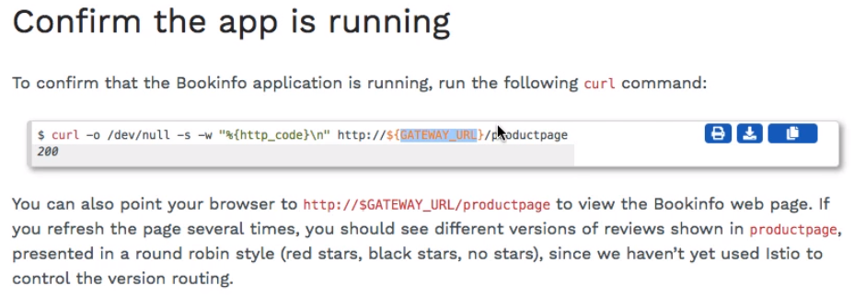

So If we check we might have to set the gateway URL, using this configuration ( highlighted below ).

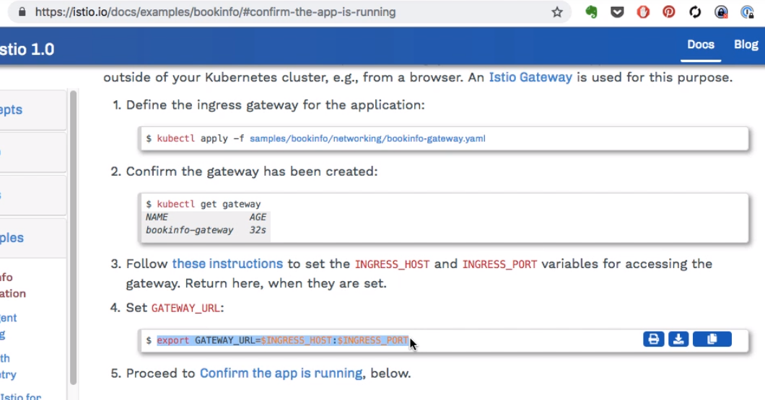

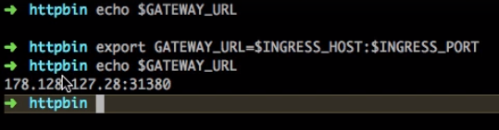

We already had the IP and the port. So now I have the gateway url and I should be able to access that application using the curl command. With the routes, obviouslyl the routes would have been defined, in the virtual services for this particular application. And I get some response should be good enough.

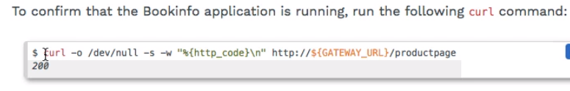



I'm going to try and access this using browser. The route /productpage has already been added and I'm going to continue using the IP Col port instead of the hostname from here and so the product page /productpage should show up and that's my application that has been deployed. I can also use for now httpbin.example.com/productpage been you know exampled arguments /productpage which gives me the same output again. So this is the book info application. This is actually the front end for the bookinfo application, it is obviously contacting or being connected with the back end as well and that's how you see the reviews and ratings on the book info page. And finally I have to apply these destination rules as well. That's part of the instruction

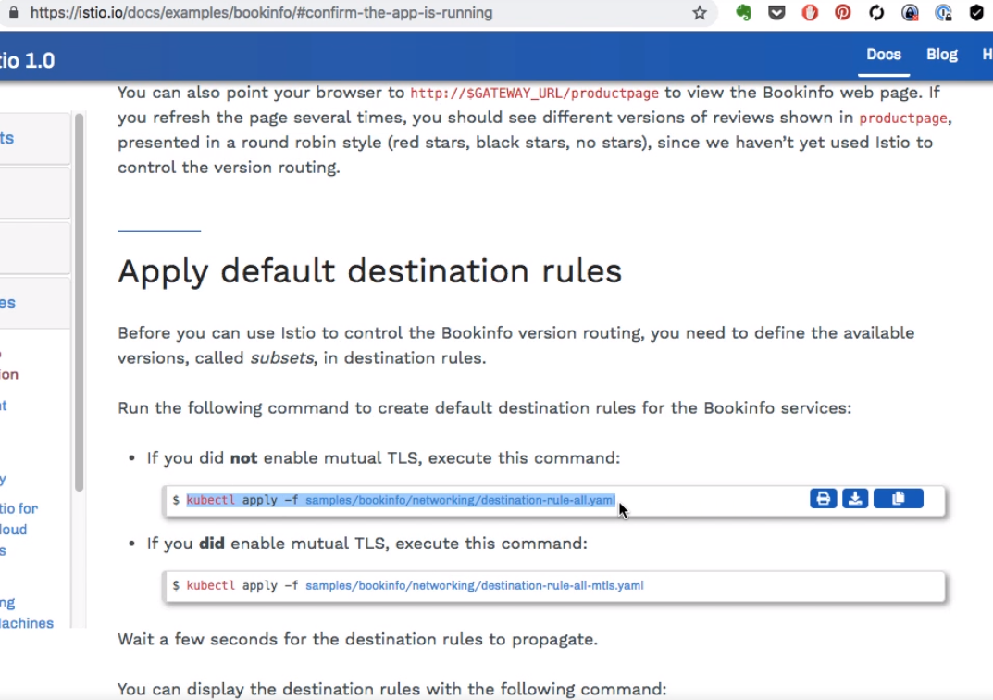

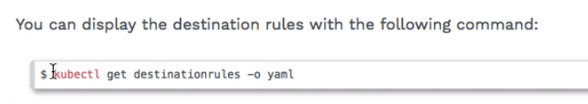

You know part of the instructions so I'm going to go ahead and apply the configuration for the destination. We generally read the routes for each of that service for the book in full application and you could always list it using the get option and you will see the different versions.

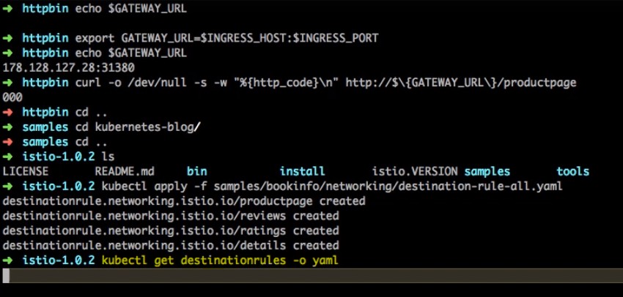

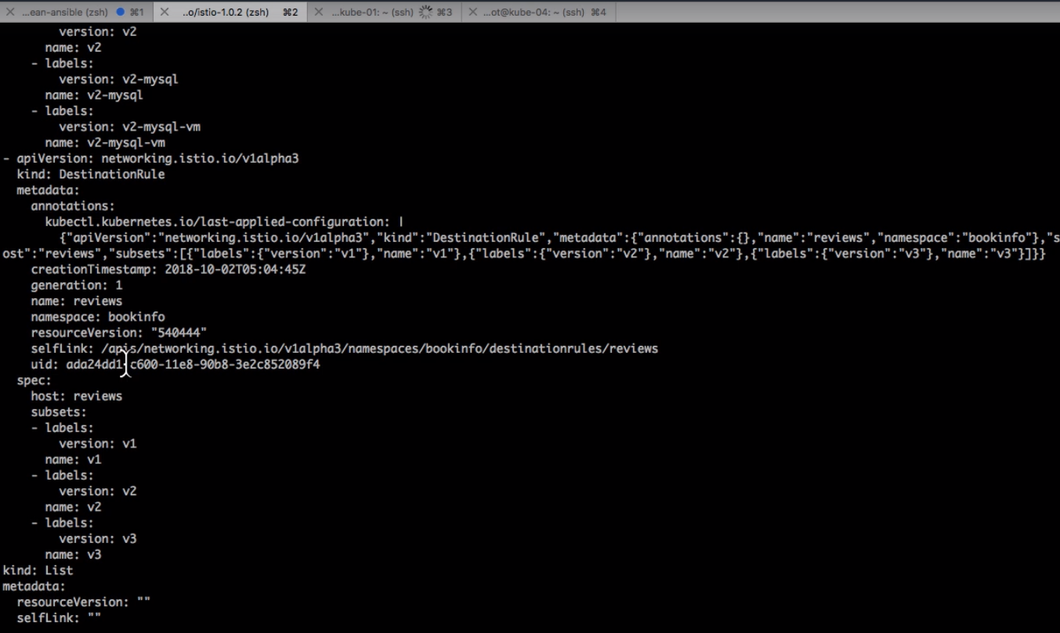

Now this completes deploying our application and we are alo able to access it using the gateway and virtual services. And this is going to be useful for you to start working on and looking at these features. So this is the fundamental setup and from here on you can start experimenting with Istio features, by looking at the examples and the next thing that we're going to start talking about is how does the intelligent routing work with you.

### Enabling Outgoing Traffic with ServiceEntry

|  |  |
| --- | --- |
|  | Let us now talk about the rules which configure the outgoing access to the external services in this case a service inside this cluster wants to talk to an external service and that's what we're going to configure. So I'm on the control egressed traffic documentation.  <https://istio.io/docs/tasks/traffic-management/egress/>  This is from the docs tasks traffic management control egress traffic and we're going to configure access to do services. Which one is this SCDP been dot org. Second is our favorite search engine that is Google dot com. That's what we're going to configure the access to and tested from inside the cluster. Now before we begin we need to deploy this sleep application. This application has to be running inside that is Geo class. And from there is where we're going to try accessing those external services. So first thing that I do is deploy this application. |

Control Egress Traffic

By default, Istio-enabled services are unable to access URLs outside of the cluster because the pod uses iptables to transparently redirect all outbound traffic to the sidecar proxy, which only handles intra-cluster destinations.

This task describes how to configure Istio to expose external services to Istio-enabled clients. You’ll learn how to enable access to external services by defining [ServiceEntry](https://istio.io/docs/reference/config/istio.networking.v1alpha3/#ServiceEntry) configurations, or alternatively, to bypass the Istio proxy for a specific range of IPs.

Before you begin

Setup Istio by following the instructions in the [Installation guide](https://istio.io/docs/setup/).

Start the [sleep](https://github.com/istio/istio/tree/release-1.0/samples/sleep) sample which you use as a test source for external calls.

If you have enabled [automatic sidecar injection](https://istio.io/docs/setup/kubernetes/sidecar-injection/#automatic-sidecar-injection), deploy the sleep application:

$ kubectl apply -f [samples/sleep/sleep.yaml](https://raw.githubusercontent.com/istio/istio/release-1.0/samples/sleep/sleep.yaml)

Otherwise, you have to manually inject the sidecar before deploying the sleep application:

$ kubectl apply -f <(istioctl kube-inject -f [samples/sleep/sleep.yaml](https://raw.githubusercontent.com/istio/istio/release-1.0/samples/sleep/sleep.yaml))

Note that any pod that you can exec and curl from will do for the procedures below.

Configuring Istio external services

Using Istio ServiceEntry configurations, you can access any publicly accessible service from within your Istio cluster. In this task you access [httpbin.org](http://httpbin.org/) and [www.google.com](https://www.google.com/) as examples.

Configuring the external services

Create a ServiceEntry to allow access to an external HTTP service:

cat <<EOF | kubectl apply -f -

apiVersion: networking.istio.io/v1alpha3

kind: ServiceEntry

metadata:

name: httpbin-ext

spec:

hosts:

- httpbin.org

ports:

- number: 80

name: http

protocol: HTTP

resolution: DNS

location: MESH_EXTERNAL

EOF

Create a ServiceEntry and a VirtualService to allow access to an external HTTPS service. Note that for TLS protocols, including HTTPS, the TLS VirtualService is required in addition to the ServiceEntry.

cat <<EOF | kubectl apply -f -

apiVersion: networking.istio.io/v1alpha3

kind: ServiceEntry

metadata:

name: google

spec:

hosts:

- www.google.com

ports:

- number: 443

name: https

protocol: HTTPS

resolution: DNS

location: MESH_EXTERNAL

---

apiVersion: networking.istio.io/v1alpha3

kind: VirtualService

metadata:

name: google

spec:

hosts:

- www.google.com

tls:

- match:

- port: 443

sni_hosts:

- www.google.com

route:

- destination:

host: www.google.com

port:

number: 443

weight: 100

Make requests to the external services

1. Exec into the pod being used as the test source. For example, if you are using the sleep service, run the following commands:

$ export SOURCE_POD=$(kubectl get pod -l app=sleep -o jsonpath={.items..metadata.name})

$ kubectl exec -it $SOURCE_POD -c sleep bash

1. Make a request to the external HTTP service:

$ curl http://httpbin.org/headers

1. Make a request to the external HTTPS service:

$ curl https://www.google.com

Setting route rules on an external service

Similar to inter-cluster requests, Istio [routing rules](https://istio.io/docs/concepts/traffic-management/#rule-configuration) can also be set for external services that are accessed using ServiceEntry configurations. In this example, you use [istioctl](https://istio.io/docs/reference/commands/istioctl/) to set a timeout rule on calls to the httpbin.org service.

From inside the pod being used as the test source, make a curl request to the /delay endpoint of the httpbin.org external service:

$ kubectl exec -it $SOURCE_POD -c sleep bash

$ time curl -o /dev/null -s -w "%{http_code}\n" http://httpbin.org/delay/5

*200*

*real 0m5.024s*

*user 0m0.003s*

*sys 0m0.003s*

The request should return 200 (OK) in approximately 5 seconds.

Exit the source pod and use istioctl to set a 3s timeout on calls to the httpbin.org external service:

cat <<EOF | kubectl apply -f -

apiVersion: networking.istio.io/v1alpha3

kind: VirtualService

metadata:

name: httpbin-ext

spec:

hosts:

- httpbin.org

http:

- timeout: 3s

route:

- destination:

host: httpbin.org

weight: 100

Wait a few seconds, then make the curl request again:

$ kubectl exec -it $SOURCE_POD -c sleep bash

$ time curl -o /dev/null -s -w "%{http_code}\n" http://httpbin.org/delay/5

*504*

*real 0m3.149s*

*user 0m0.004s*

*sys 0m0.004s*

This time a 504 (Gateway Timeout) appears after 3 seconds. Although httpbin.org was waiting 5 seconds, Istio cut off the request at 3 seconds.

Calling external services directly

If you want to completely bypass Istio for a specific IP range, you can configure the Envoy sidecars to prevent them from [intercepting](https://istio.io/docs/concepts/traffic-management/#communication-between-services) the external requests. This can be done by setting the global.proxy.includeIPRanges variable of [Helm](https://istio.io/docs/reference/config/installation-options/) and updating the ConfigMap istio-sidecar-injector by using kubectl apply. After istio-sidecar-injector is updated, the value of global.proxy.includeIPRanges will affect all the future deployments of the application pods.

The simplest way to use the global.proxy.includeIPRanges variable is to pass it the IP range(s) used for internal cluster services, thereby excluding external IPs from being redirected to the sidecar proxy. The values used for internal IP range(s), however, depends on where your cluster is running. For example, with Minikube the range is 10.0.0.1/24, so you would update your ConfigMap istio-sidecar-injector like this:

$ helm template install/kubernetes/helm/istio <the flags you used to install Istio> --set global.proxy.includeIPRanges="10.0.0.1/24" -x templates/sidecar-injector-configmap.yaml | kubectl apply -f –

Note that you should use the same Helm command you used [to install Istio](https://istio.io/docs/setup/kubernetes/helm-install), in particular, the same value of the --namespace flag. In addition to the flags you used to install Istio, add --set global.proxy.includeIPRanges="10.0.0.1/24" -x templates/sidecar-injector-configmap.yaml.

Redeploy the sleep application as described in the [Before you begin](https://istio.io/docs/tasks/traffic-management/egress/#before-you-begin) section.

Set the value of global.proxy.includeIPRanges

Set the value of global.proxy.includeIPRanges according to your cluster provider.

Google Container Engine (GKE)

The ranges are not fixed, so you will need to run the gcloud container clusters describe command to determine the ranges to use. For example:

$ gcloud container clusters describe XXXXXXX --zone=XXXXXX | grep -e clusterIpv4Cidr -e servicesIpv4Cidr

*clusterIpv4Cidr: 10.4.0.0/14*

*servicesIpv4Cidr: 10.7.240.0/20*

Use --set global.proxy.includeIPRanges="10.4.0.0/14\,10.7.240.0/20"

Azure Container Service(ACS)

Use --set global.proxy.includeIPRanges="10.244.0.0/16\,10.240.0.0/16

Minikube

Use --set global.proxy.includeIPRanges="10.0.0.1/24"

Access the external services

After updating the ConfigMap istio-sidecar-injector and redeploying the sleep application, the Istio sidecar will only intercept and manage internal requests within the cluster. Any external request bypasses the sidecar and goes straight to its intended destination. For example:

$ export SOURCE_POD=$(kubectl get pod -l app=sleep -o jsonpath={.items..metadata.name})

$ kubectl exec -it $SOURCE_POD -c sleep curl <http://httpbin.org/headers>

Understanding what happened

In this task you looked at two ways to call external services from an Istio mesh:

1. Using a ServiceEntry (recommended).
2. Configuring the Istio sidecar to exclude external IPs from its remapped IP table.

The first approach, using ServiceEntry, lets you use all of the same Istio service mesh features for calls to services inside or outside of the cluster. You saw this by setting a timeout rule for calls to an external service.

The second approach bypasses the Istio sidecar proxy, giving your services direct access to any external URL. However, configuring the proxy this way does require cluster provider specific knowledge and configuration.

Cleanup

1. Remove the rules:

$ kubectl delete serviceentry httpbin-ext google

$ kubectl delete virtualservice httpbin-ext google

1. Shutdown the [sleep](https://github.com/istio/istio/tree/release-1.0/samples/sleep) service:

$ kubectl delete -f [samples/sleep/sleep.yaml](https://raw.githubusercontent.com/istio/istio/release-1.0/samples/sleep/sleep.yaml)

1. Update the ConfigMap *istio-sidecar-injector* to redirect all outbound traffic to the sidecar proxies:

$ helm template install/kubernetes/helm/istio <the flags you used to install Istio> -x templates/sidecar-injector-configmap.yaml | kubectl apply -f -

### Understanding service to service communication in mesh

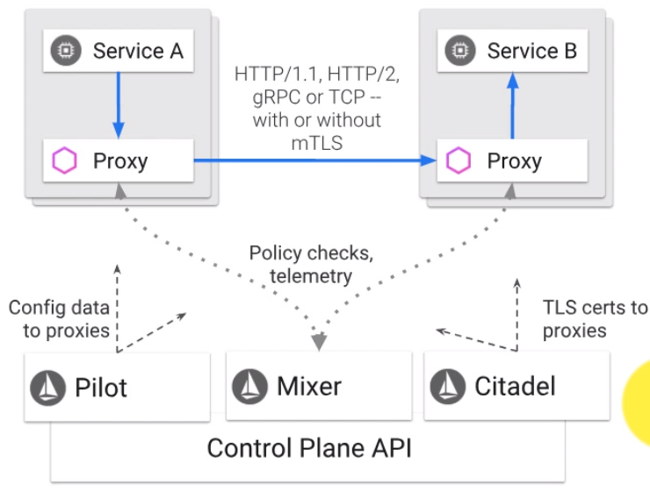

Let’s see how the internal communication between services inside the node cluster works, before we do that,we have already configured these for Nodes, it's running all this and these are the names spaces and I'm going to list the pods running inside this cluster which includes the book info application or the service and the application that has been deployed for this book info sample application.

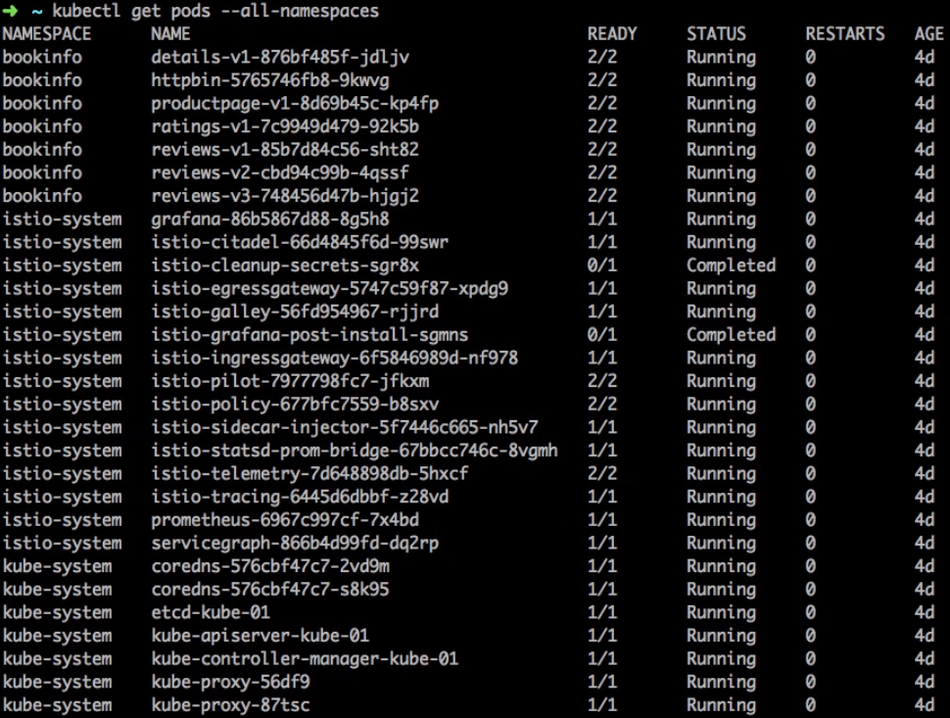

Along with that this is your control plane and the K8s control plane running here as well. Now the key part here for the service to solve is communication inside the two clusters is the proxy and that is where this proxy called as Envoy comes. Envoy was a proxy created by Lift as an organization and that connects then to the Istios control plane which includes pilot, mixer, citadel and so on and so forth.

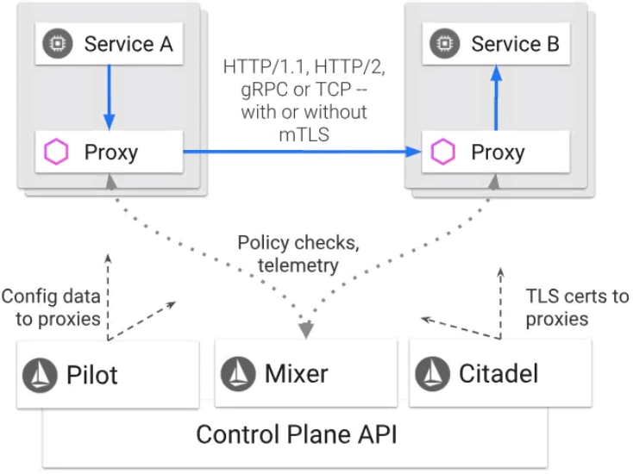

In order for you to understand how Envoy works you can also have a look at www.envoyproxy.io to get an in-depth understanding of how things work and why and it has a great amount of documentation right here.

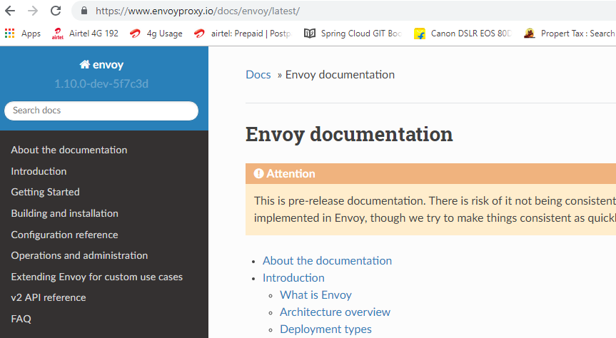

And if you want to understand the concepts such as what is a listener, what is it out that has been configured and how things work with Envoy. This probably is a great source to understand or go in-depth into Envoy.

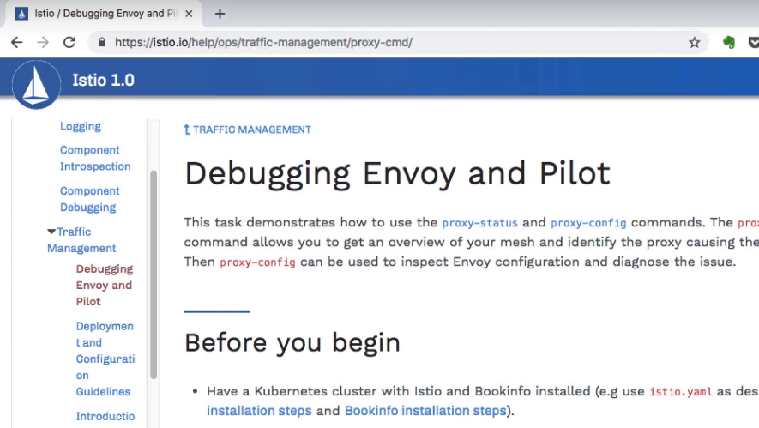

Now I'm going to give you just enough understanding of how Envoy works with the next two or three videos and the first thing that we do, I'm going to switch to my Istio environment right here and there is a documentation which talks about debugging and Envoy and Pilot. And that should help you get a better understand how things work with Envoy and how does it manage the communication between the services and how it does that by injecting for every pod in case of K8s , inject its own prox service which is the Envoy and that is the one which will start taking care of the communication.

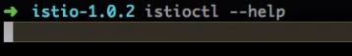

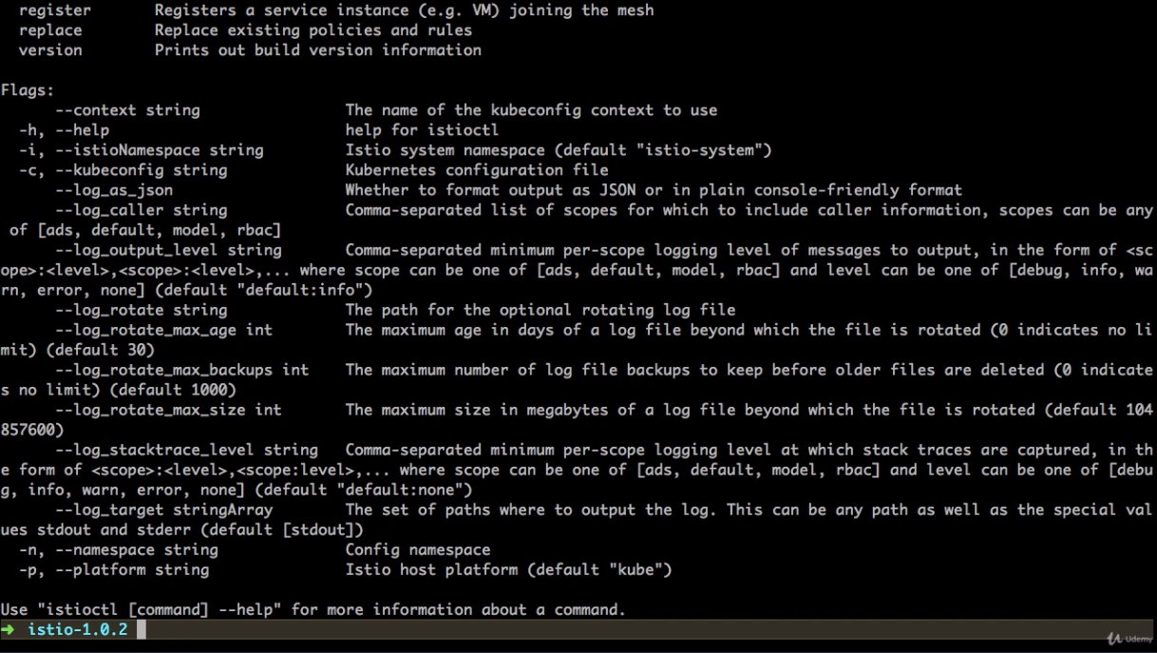

And if you want to find out the current status, you can use it you see it as a command line and two important commands here are proxy -config and proxy –status. So we're going to begin istioctl proxy status. And this should show us the current status of this environment with Istio Cluster.

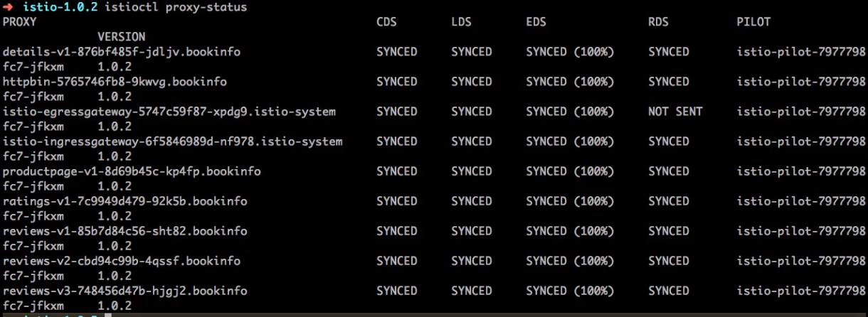

And if you run proxy status it currently shows me that the list of services which are being managed by Istio which includes a complete book info application, ratings, reviews and so on and the status of it, what you see in the second column onwards is the status of the Envoy proxy with respect to the pilot, because pilot is the service is Istios control plane which sends the troughs and the rules and changes to each Envoy proxy.

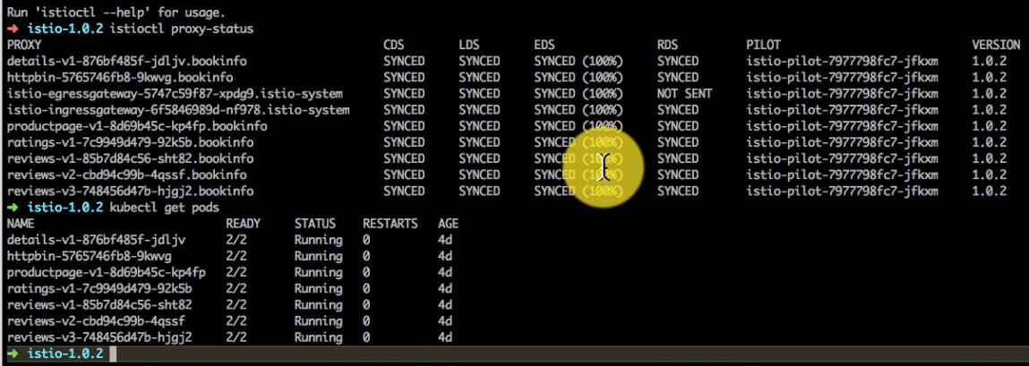

So what you see here is SYNCED, is all of these are working absolutely fine there's 100 percent in sync with the pilot configuration. Sometimes if you see NOT SENT as a configuration there is nothing that pilot has to say and do this and by proxy configuration for that particular service and you can read about the status in details here sinked not Synched if the configuration is in or not up to date.

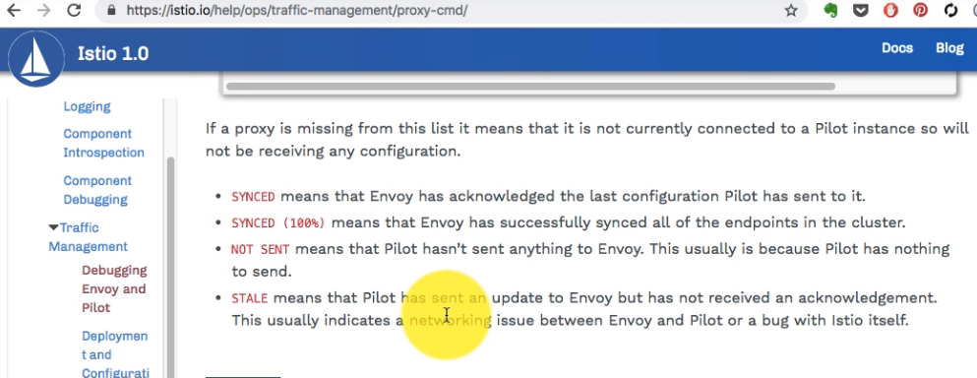

It might have a Stale status if your configuration is not up-to-date. If you want to find out the diff between your proxy service configuration and you’re the pilot configuration, you can also use this particular command so istioctl proxy status gets you the list of the pods and the services and then you can run istioctl proxy status reviews.

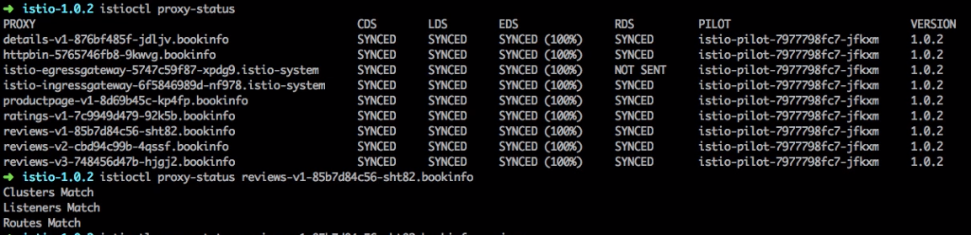

If you look at that it says Gloucester's mercilessness match or outsmarts everything is up to date. You can also use –json to get the desired output for most of these commands. So this was just a diff between the Envoy and Istio pilot. If you have a diff you'll see that displayed right like this. If not it's just gonna show you the status like I I saw it on my screen.

Now If you want to take a deep dive into the Envoy configuration and the proxy configuration in general you can use these proxy config command instead of proxy status.

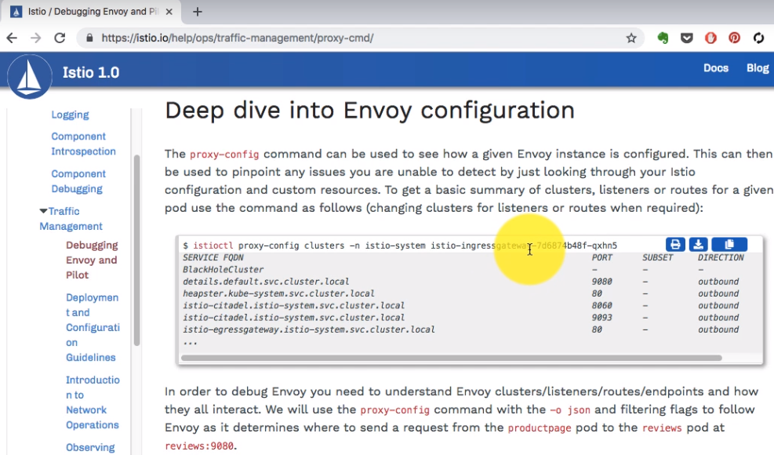

You can start using the proxy config command which will show you a great deal of information about the proxy configuration and how things work with it which ports and listeners have been created which routes have been created as well. And that's what we're going to start digging deeper into. So I'm going to run that and get pods command first and find out what's there in your system. So I have let's say ingress and egress gateways. I'm going to list the configuration for the ingress gateway pod.

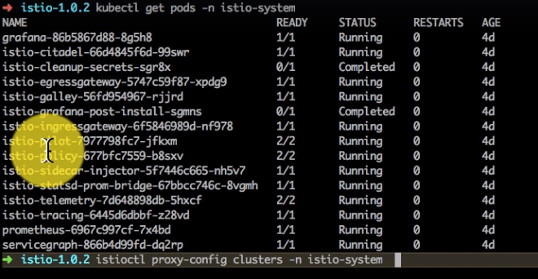

That's what I do here istioctl proxy-config clusters. Clusters is a command for proxy config. And then I provide the namespace which istiosystem and ingress gateway pod details. And this shows me the listeners and the configuration for that e-address Gateway as a pod configured by Istio and this has the outbound and inbound rules as well and it is what you see on the left hand side are the routes and the pods basically which have been configured and the list of ports in the second column as well.

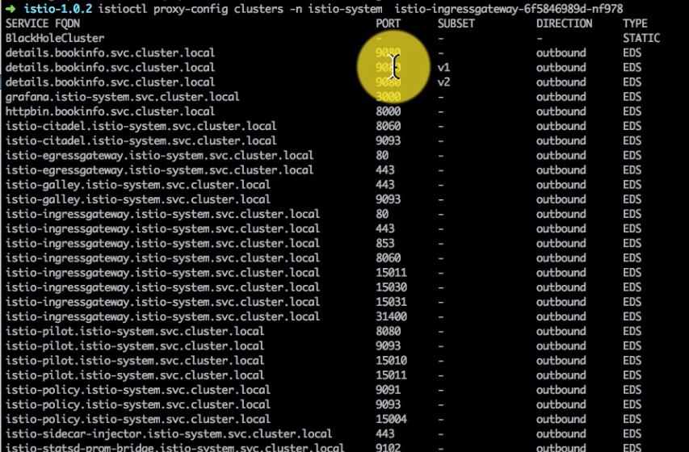

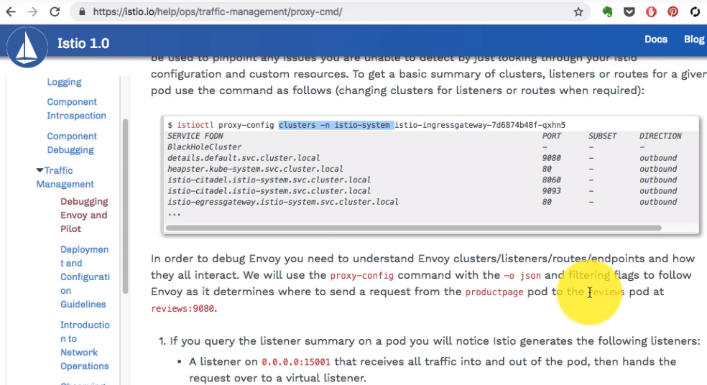

Let's try to actually find out a route between the productpage interviews because this we have deployed an application that is book infor and you can all go to the examples booking application. And what we're going to traverse is the route between product page and reviews. So we'll go and look at the product page as an application and find out how it routes the traffic to reviews through envoy and see if they list the services

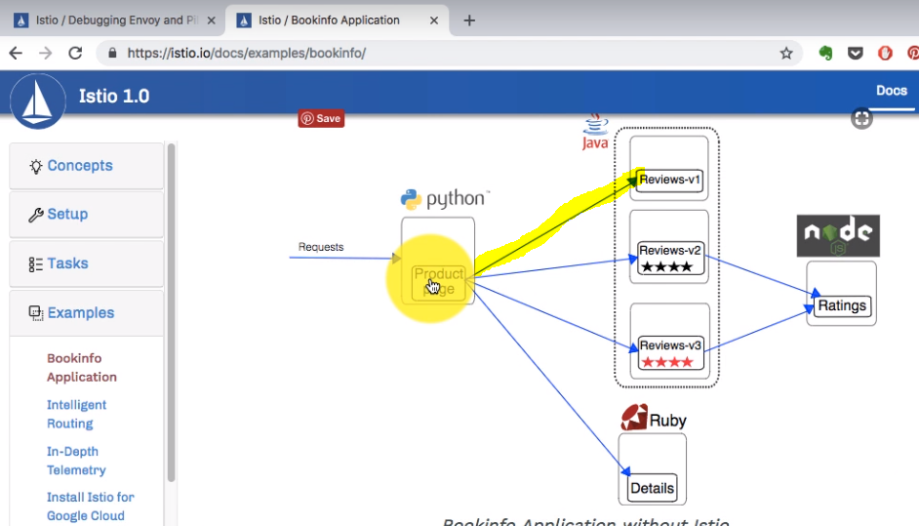

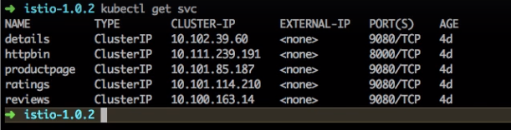

I have reviews which is running in 9080, in fact all my services almost all the services are running on board 9080. We're going to come back and look at that as well. And then find out how the traffic is getting out here. So the service actually always sends to traffic all the traffic coming out of their service is actually hijacked by Envoy and then we start managing that traffic using the rules provided by pilot and pilot is the component of the Istio control plane.

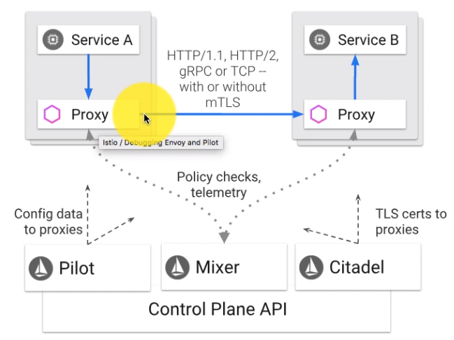

So I want to find out to the listeners, listeners are the ports - you know the host and port configurations - the port configurations that this particular service is listening on listening to the proxy that is. So istioctl proxy config and I can't find out listeners. I showed you an example of the clusters earlier. That is a cluster configuration. This is about the you know the listener configuration for a specific port that is part of page we want to find out product page to reviews configuration.

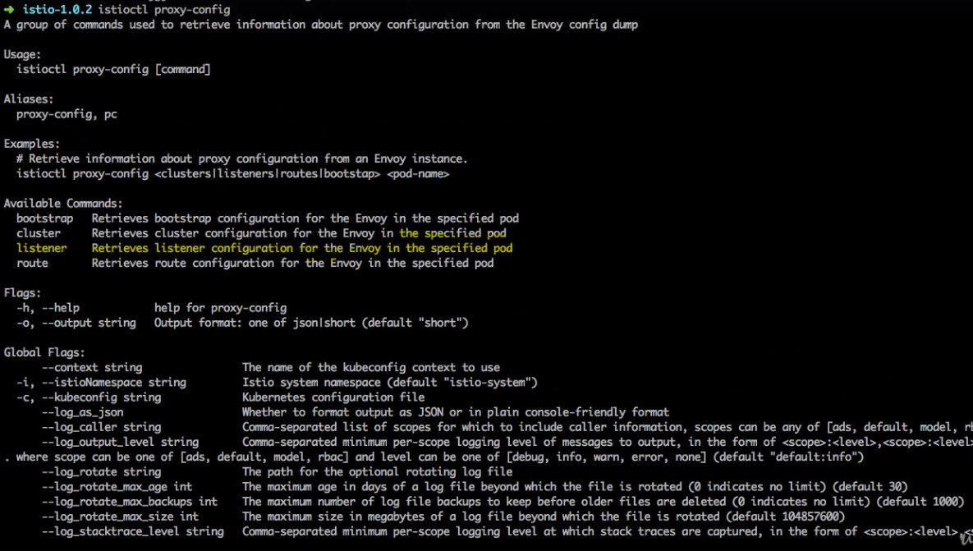

So first we'd start listing the listeners for product page and I see a bunch of ports and host port configuration here.

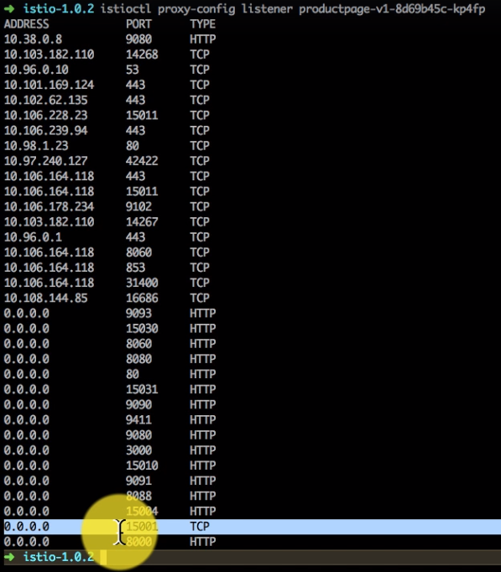

These are the listeners created by Envoy and the most important one is the 15000 one all the traffic is actually being sent to Envoy on this port. And from there it creates these listeners I'm going to show you how that works with IP tables in the next video.

### Deep dive into traffic forwarding rules for envoy proxy

In the previous video I started showing you the listeners for the productpage as a service. And one of our listeners is 15001, all the traffic I mentioned that has been sent to this envoy's 15001 port listener. Now how does it manage to send hijack all the traffic from the service from the productpage application for example is what we're going to look at. And in order to understand that we need to go to the host that is running that particular port. So I found out the port where it started running on which is kube03 in my case.

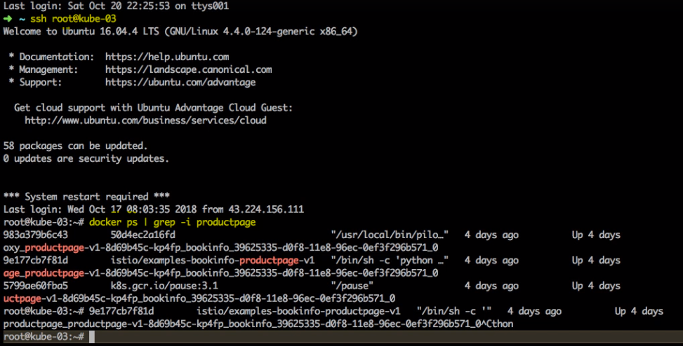

So I go there and if I list the containers, all the pods are running as containers and if I list containers I have two containers running for product page, this is the first container. This is the one which is running the actual application. The second one which is in paused state is just for the network namespace as a configuration. So what I want to do is connect to the container running productpage and here I'm going to list the IP tables.

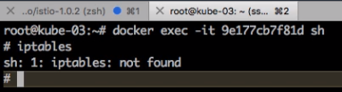

Now a lot of times this is what is going to happen so you won't find the necessary utilities inside that particular port because most of the images are created with the stripped down version of the operating system. But I can suggest you a very useful tool here so if you just search for nicola netshoot that is a very interesting tool here, this is very very useful tool for troubleshooting including the network troubleshooting because it comes with all of these utilities including IP tables and a lot more abilities which are very very useful for troubleshooting.

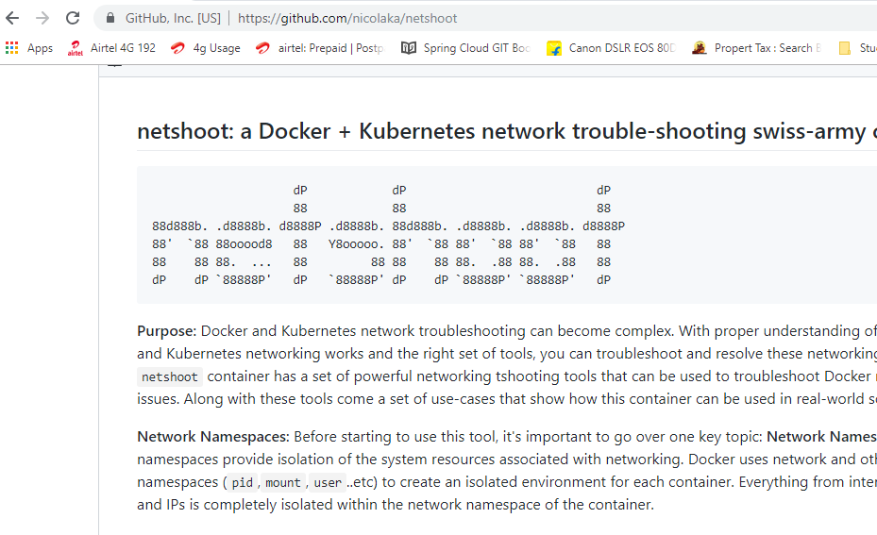

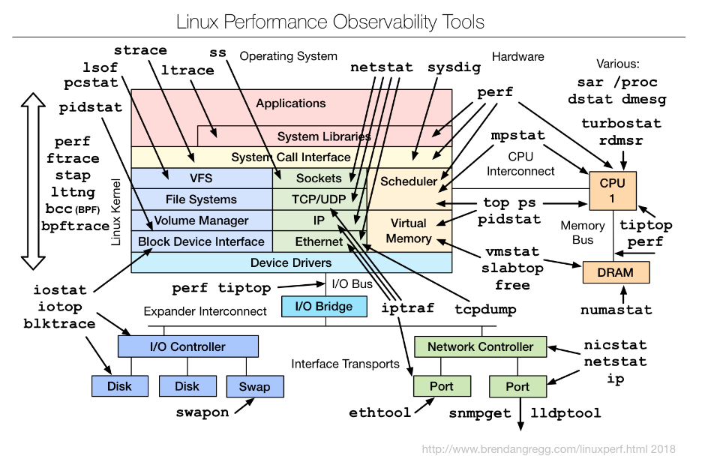

And what is interesting is docker actually allows you to connect to some other container. So what you can do what we're essentially doing here is launching this container with this image Nicole Netshoot, and connect to another container. In this case it's going to be the container running the productpage as an application. Since we don't how IPTables inside we will use an image which has IP tables but connect to this containers namespace which is really interesting.

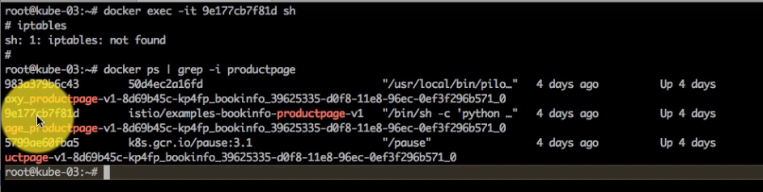

And once we're in there to validate that it's actually this container. So I'm going to use docker run nicola netshoot in the container column, the container name is where I would be just the container ID for the product page which starts with 9e177.. in my case. So I need to go to the host again and then connect it this way. You have to use --privileged in order for IP tables to work. And now if I run, but before even I run IP tables, I'm going to show you that I'm in the right pod and the right container - by running ifconfig this is 10:38:0:8 which is the IP of my pod for the productpage. What it means is even though I'm using the I'm connected to the network of that particular pod.

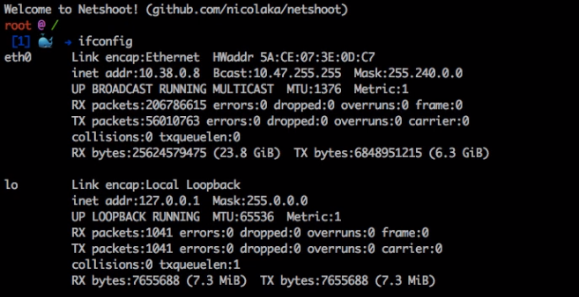

And now if I run iptables –nvLt –t nat, I should see the IP table rules.

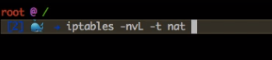

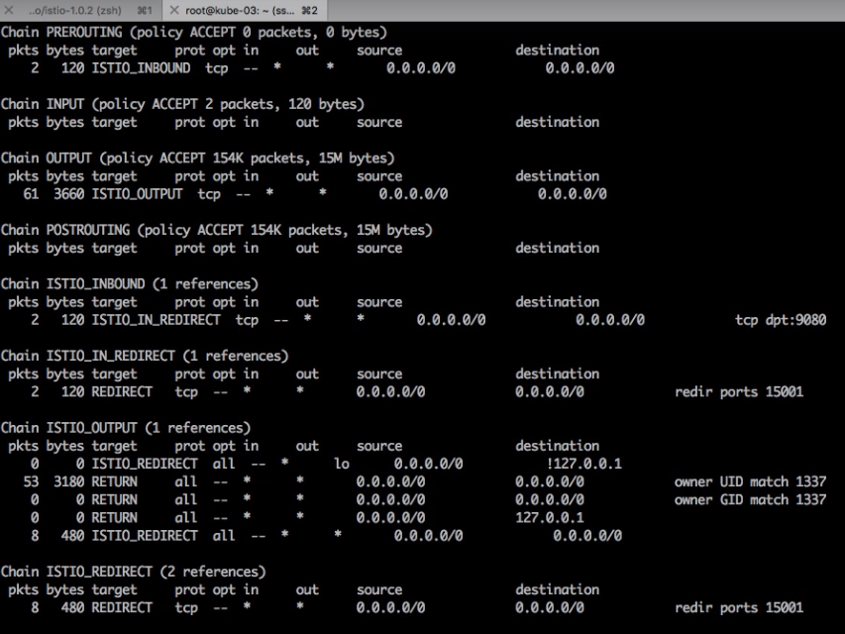

And the most interesting one, so there is an application running on 9080, that's where I see here. And the most important rule here is this 15001. So if you see that all the TCP traffic, all the traffic actually is being routed to the 15000 port which is where Envoy is listening. And this is how it works. This is how it gets implemented. So when you look at Istio, Istio has injected the proxy as the container in my pod for the service. And inside that it has also set up these IP table rules so that all my traffic for that service is actually being managed by Envoy. And this is how it is routing and sending all the traffic to Envoy.

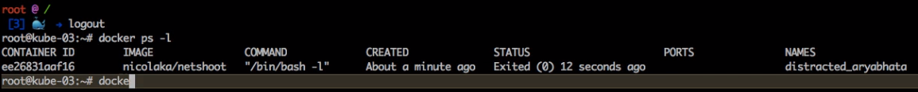

|  |  |
| --- | --- |
|  | So if I come back here this is when I was showing you the parts and the details and the listeners here. This is where we looked at the board you know 15000 of one being listened to and everything else, so whatever out going connections I have all that, for each of that Envoy is creating a listener for that and that's how this traffic gets routed including the traffic for the reviews and all the other application. And that's what we're going to look at in the next video, how the traffic gets red from productpage to the reviews application. |

### Tracing routes from productpage to reviews with istio configurations

We're going to traverse the road between the product page and the review system through Envoy and Pilot configuration provided by Istio. So we looked at all the traffic being sent by 15001 to the IP table. And now we're going to start exploring how the rest of the configurations including the routes work and what do you also see here are listeners for TCP and HTTP services, so if the product service is asking for any of the externals services or anything that it needs to connect to it goes with the Envoy.

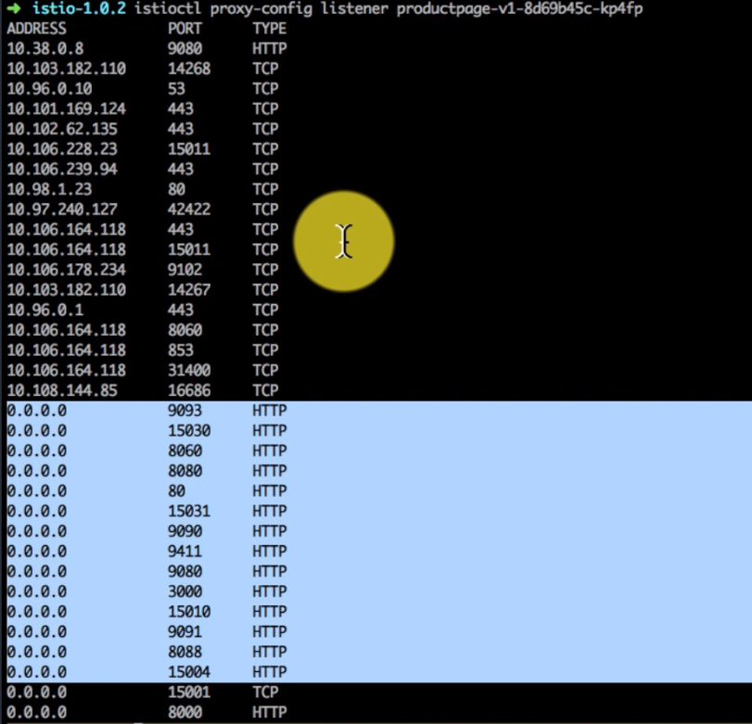

And then Envoy creates a listener for each of the services destination that it is trying to connect to. And that is what you see here in the form of listener configurations, you can actually find out the listener configuration are the configuration for that 15001 port that the Envoy is listening to.

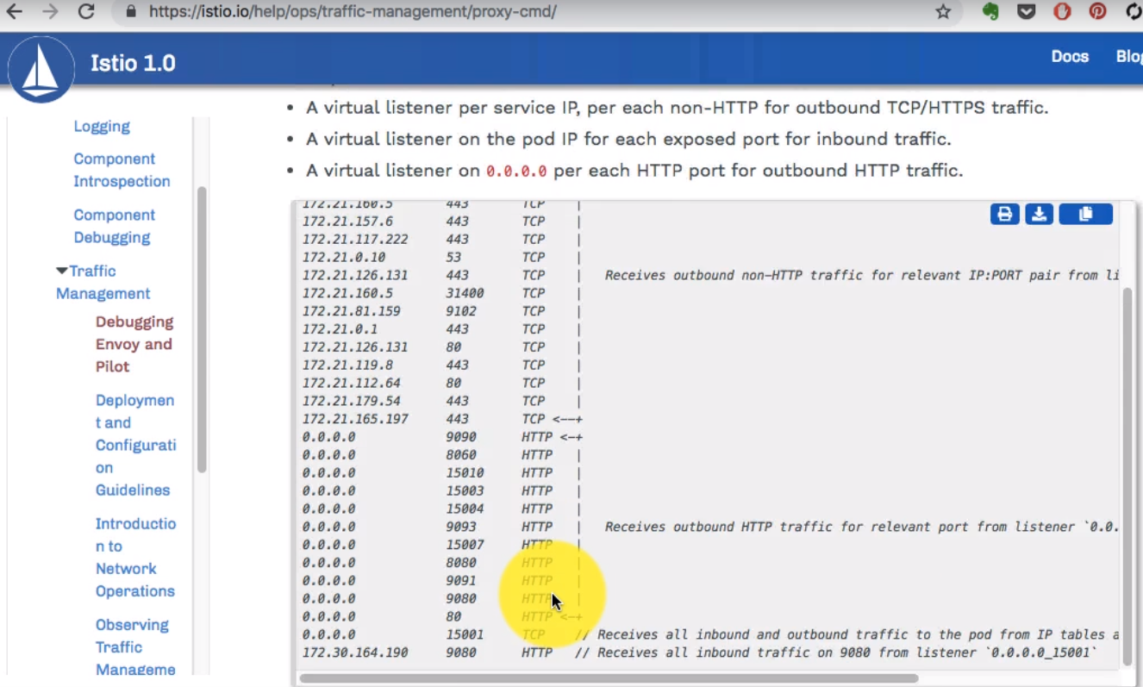

So you can use proxy config, listeners configuration and we're looking at the productpage pod configuration. Now what do you see in this documentation will vary from what you would have to run because your productpage pod is what you have to use here.

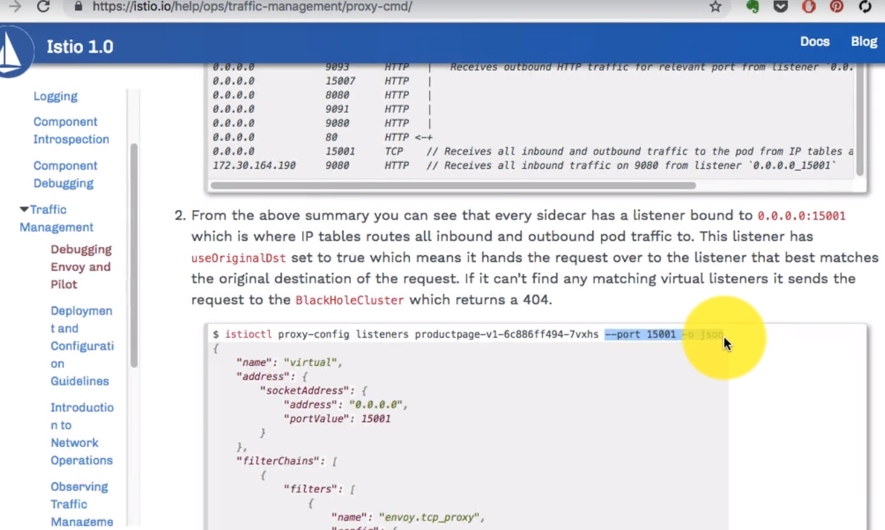

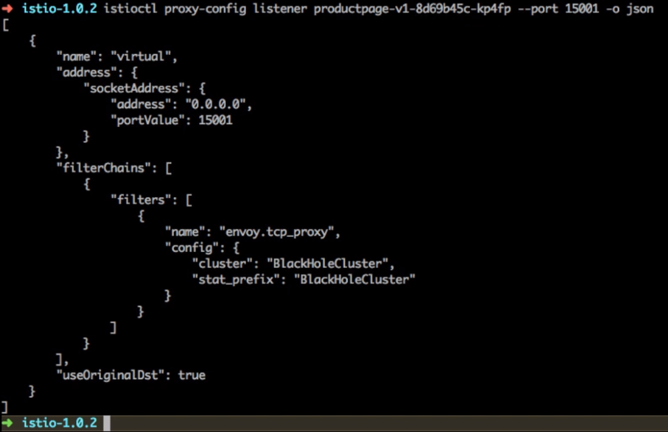

And if I look at this configuration, it shows me that it's listening to port 15001 and it is using this configuration, use original host or use our original destination through, which means that if that is the definition of it is reachable for the end of the service is asking for it is going to work that way. If not it is going to send to the black hole cluster. So that configuration is for any other traffic which is not available will go to the black hole which means that it's not going anywhere.

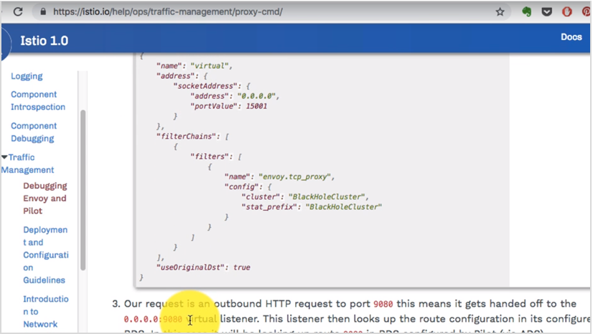

Now it's time to traverse from productpage to their views configuration again. We're going to look at the you know the configuration for that port 1980 for any address, so we're going to look at the listener configuration basically. So we have listed the listeners, we're going to pick one off that listener which is sending traffic that address as 0.0.0.0 which means all the host and 1980 so that's what because you know looking at the configuration for –port=1980.

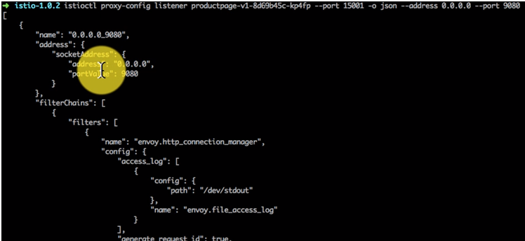

Scroll down below

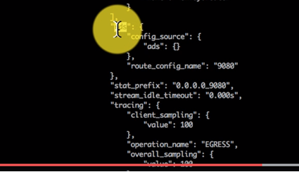

Now what this shows me is what is a configuration provided to Envoi by Pilot and that is where I see for 1984 as a destination with host and 0.0.0.0. It has configured RDS as our route discovery service here. And the name of RDS or Route discovery service is 1980. So the next thing that I need to do is find out the route information for this our route discovery service, through istioctl proxy config router configuration instead of Listener now we're going to look at the router configuration, so it's a proxy config that routes as the command.

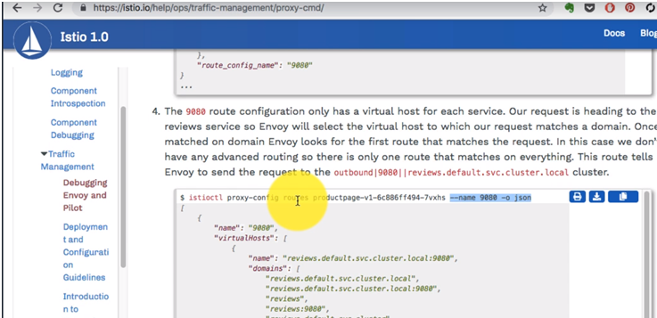

Let's find out more information about that RDS with name 9080. Not port but the name. So I'm going to change the command to display information about route and then I'm going to remove that dress. I just want to find find out the configuration for the name Hi 1980. That is the ideas being used for that particular service. That type of knife and port to name and what it shows me is any what has been configured for that discovery service so anything which is being sent to 9080 will go through the listener and it's going to send the traffic to multiple destinations so there are different services which have been discovered as part of that discovery service and one of that service is the the details, details is part of the service or anything but just listening or 9080, is listed here as being discovered at that service which also includes product page which itself is listening to port 9080.

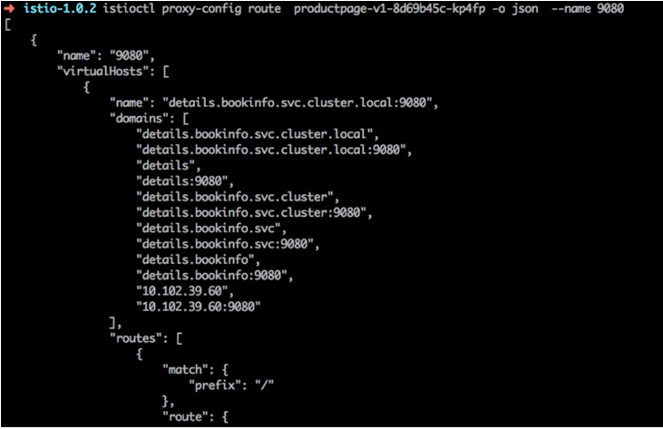

Apart from that we have ratings and reviews so what we are concerned about here is the path to reviews, even though we're trying this from productpage we want to find out the path to reviews, and that is where the service has been discovered with the name the reviews.bookinfo. there's a cluster name, there's a istion.io, there's a whole full fully qualified domain name. And this is where you'll find the listeners right, so all of the services are listening to 9080 and that is the hostname.

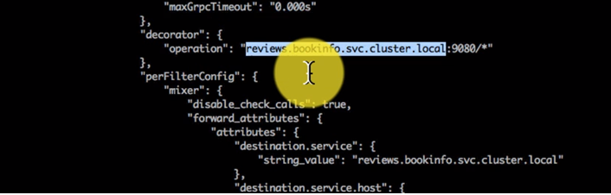

Now I want to find out, the last part of this is through Envoy the service is going to reach out to the reviews so how does it find that out the route. What is that out it's going to take. And if you want to find that out that route path out, you can always look at the route from a particular pod to a particular FQDN. So what I'm trying to do here is just as you know istionctl proxy config clusters, cluster information from this pod to a FQDN. So if you look at the documentation the command is incorrect. It misses that pod productpage part.

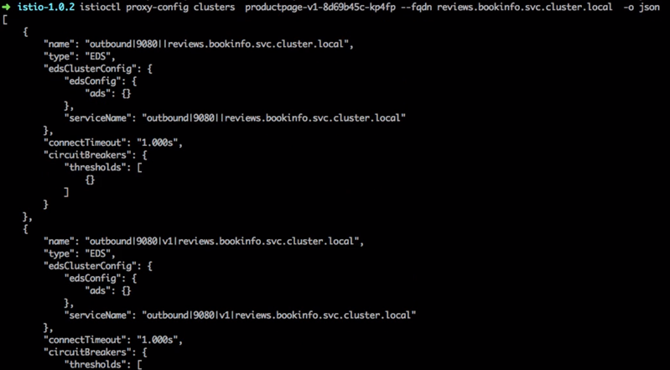

So I have added that and from there I want to find out the FQDN which is what I've discovered through that route discovery service, and this shows me all the routes. You know it's going to take these other routes. It's basically it would take for the reviews service and review service can actually go to multiple versions because that service has been configured in the virtual service configuration to Route to be v1, v2 and v3. And I see the individual entries for those domains. So what we just analyzed is how Envoy proxy works and how you can connect communicate from one service to another and each service has the load balancing configuration with the actual endpoint. It is unlike K8s, it is it's not going to intermediate service - it is directly connecting to the actual pods. And that is the configuration which has been provided by pilot and registered by Envoy.

### Importance of application resilience and use case

Your services when you build those have to be resilient - resilient to the failures. It should detect and handle the failures gracefully and without causing the downtime of your application. I'm just going to explain this with one of the use cases. This is Flipkart.com, it is one of the largest marketplace e-commerce marketplace in India. And every year they have a sale during the festival season. They call it big billions day, millions of customers and billions of transactions a day almost. And the first first year they did that in 2014 and the first day it was launched. It just crashed their systems, crashed and it was because of some services being not available and it probably had a cascading effect on their complete system.

Now this years in 2008 they've done spectacularly well and in this article what drew my attention was how they handle the failures and resiliency to the system. So they mentioned that, the system doesn't fail because of one service in fact they had it in a very graceful way and even if they are running out of capacity, they remove certain services like personalizaion or geo-location and their application is resilient to those services not being available. Personalization can be lets say I'm logged in here and since I'm logged in I might have searched for something related to iPhone so I see my recommendations which are specific to me. This probably comes from a recommendation service and if they have high traffic, very high traffic, they'll just you know shut down that service and what would happen is my page would not get affected in my latency it would just load faster. But I might not see certain feature and that is just one way of adding resiliency to your services and the you know there are many ways to make your services resilient and fault tolerant.

We will talk about three of such features. Let's look at the first feature which is about timeouts timeouts are really important and that much can be defined at the application level or Istio, Istio itself does that at the infrastructure level which means that your developers don't have to worry about that, it can be done at Infrastructure level using Istio. And what is going to happen if you compare the first diagram with the second diagram - what happens here is in first diagram the user makes a request to services and service A has a downstream service – Service B, which has to connect to that and get some reply back, maybe using a RPC and then get the reply back and then send it to the user.

|  |  |
| --- | --- |
|  | Now what happens if the latency goes up for example if Service B has a problem or there is a network issue between B and A, and the latency keeps going up let's say latency is 10 seconds. If you have it by more than 15 seconds it's still OK, and it will read 10 seconds added 2 seconds for the process time of Services. So the response to the user is about 12 seconds. If you look at the second diagram you can actually manage the timeout at Istio level as well. And if I set the timeout as 3 seconds, if the latency goes up, the regular processing time is 2 seconds. But if there's a latency, if it goes up let's say the latency right now is 10 seconds. |

You don't want to wait for that request to come back and add it to the user's time, because if you're on an e-commerce platform if my page takes like 12 seconds to load, I might just go to another platform and another site if I'm pretty sensitive to that the request and response time and the users might just go to another competitor.

So instead of that, the way it should be handled is, it should have a reasonable time out and the moment latency goes up or if the service is not responding in that time, it should just return back and handle it gracefully. Maybe not showing that component that's what we discussed about Flipkart. You know the way it manages their services is if it does not respond, if it is not available, it will just handle it gracefully and not display that part of the page which is OK for me then getting a longer response after let's say 12 seconds. That is how timeouts can work out, to handle errors and issues then there is high latency

The second feature which we could add for resiliency to your application is Retries. Now again if you compare the first versus the second diagram, in the first diagram the service a connects with external service lets say its a map API service which connects to the Google Maps and then gets the response.

|  |  |
| --- | --- |
|  | Maybe its Uber application which needs to show the maps and it is connecting to backed maps service somewhere. And let's say there is a network issue there. In the first example there is not retry defined here and so it is going to try to try once and there is an intermittent network issue. So it just does not get any response and the user sees an error versus if I don't retry if we look at the second diagram it's the same scenario but you added a retry and let's say the second time you're trying out the service back the API, the network has recovered and it gets back the response and the user gets the correct response, so retries in addition to timeouts are also very important. And this can make your application available and it will keep on checking & retrying until the backend services available. Obviously you will have to at a reasonable time out of period for each retry as well. Again you can do that on its own without making any changes to your application. |

A third useful feature to have is a Circuit Breaker.

|  |  |
| --- | --- |
| Now in the first example if you see that service B has a capacity of 50 connection, it can handle only 50 connections at a time. And let's say they're sending hundred connections to it, in the first example what is going to happen is, it is flooding the service - service will start taking more load, it will have increasing amount of latency and that would affect your overall application versus if you set a circuit breaker with the reasonable capacity and maybe some buffer in the second example, if you look at that we have set a circuit breaker after the maximum connections as 50, so until that limit reaches the services we'll accept service. We'll keep on accepting that connection. But the moment it exceeds or maybe the reasonable buffer it is going to stop responding and accepting those connections and what is going to happen is they can then handle gracefully. |  |

It knows that it is this service, that is not responding, it doesn't have to wait for that service to come back with added latency and it can handle the failure on its own, maybe just not displaying that part of that obligation or handling in some other ways or triggering a scaling event which could launch new new instances of B. And only then it will start sending the traffic to it, so it can gracefully handle the errors and all of this again, is built into Istio in all mesh services offerings and you don't have to make those changes in the application which is much more complex to do. So you can take any Microservices and you can add all of these features with Istio by default out of the box without your developers burdened to manage these network related configurations as well. And that's the advantage of using Istio. Lets see how these features work with a sample application.

### Configuring and handling service timeouts

Lets see how to configure time outs between services and for that I'm going to go to traffic management from the tasks traffic management and section request time outs to refer to.

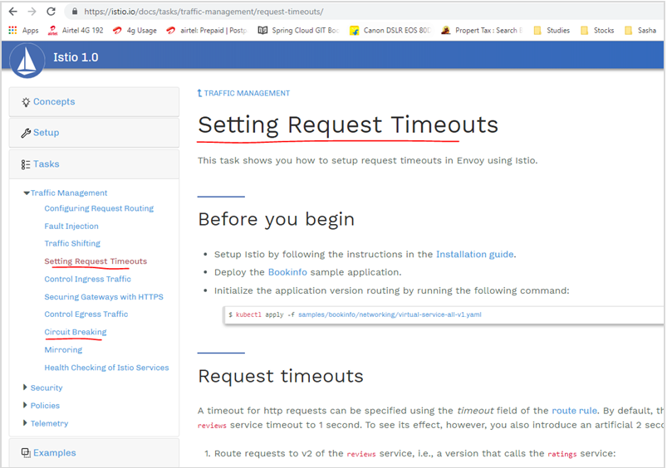

We've already taken care of most of the the configurations. And I'm going to apply this kubectl command here just to make sure that everything is in order because I might have changed some of the configuration for some of these services, even though these have been deployed. So I would apply that and then start configuring the request timeouts, so timeouts the way it is going to work is this way.

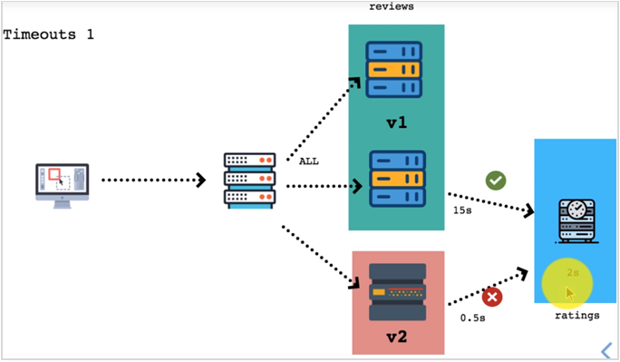

So I have two versions of reviews v1 and v2, and that sends the traffic to ratings, so the product page comes to reviews and reviews fetches the ratings from this service in blue box, so this service has a a timeout so I'm going to add a delay or a fault by two seconds so response time would be two seconds. Now that timeout configured by default is 15 seconds in which case this is going to work OK, but if I have a service with a timeout configuration, if it times out at let's say half a second, it's definitely NOT going to work because this rating service is going to take two seconds and that's what I'm going to demonstrate here.

This situation is what we're going to create by adding a fault in the rating service and then by changing that timeout in the reviews service. First of all let's have a look at the current configuration, so I'm going to send traffic to v2 for the service, currently it is at v1. So this is my product page you know and then I'm going to set to auto refresh using a chrome plugin. It is refreshing this page every three seconds and what I see is the first version of this reviews application because the first version v1 does not show any ratings whatsoever.

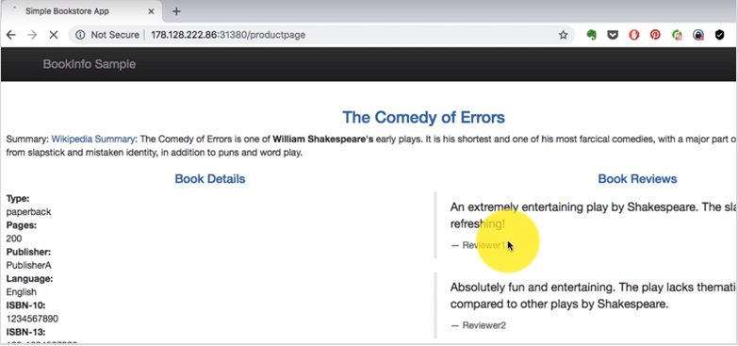

This is the default configuration for this cluster and if I keep on refreshing this page I have enabled auto-refresh and if I keep on refreshing this page. I still see v1 and I'm going to change that, so that the route in virtual services sends the traffic only to v2, I can get details about that virtual service using istioctl or kubectl get virtual service which is for reviews.

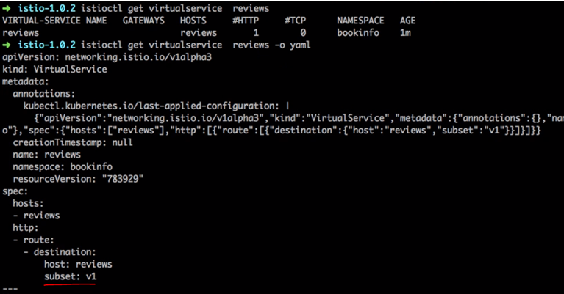

And if I look at this, this is going to show me what it is pointing to. Right now it is just pointing to the subset v1 of this application. And this is what I need to change. So I'm going to just apply that and again display the same output this time I see the subset v2 and it is it all going to v2 and since this is auto-refreshing it, it is already pointing to v2 for fetching the reviews, it doesn't show those red stars, we see a red red asterisk it doesn't show the actual rating that just has those placeholders for the ratings which is those black stars. So it is fetching the ratings and it is the version 2 of my application. Now this is the ratings configuration.

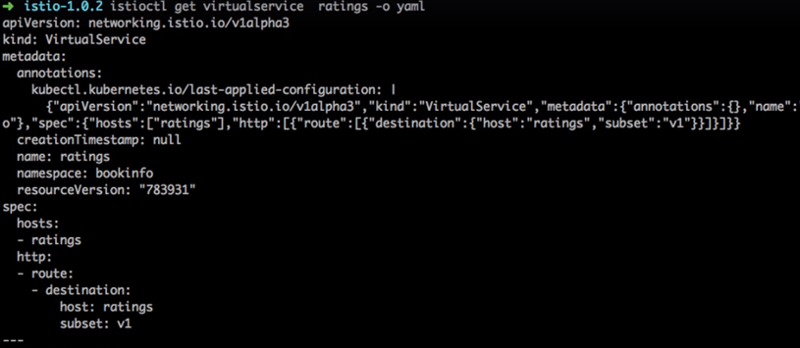

This is where I'm going to add a fault. So you can introduce a fault and the fault this time is a fixed delay, there are two types of files you can inject one is a delay and the second is a fault. In case of delay, it is going to simulate a situation where there is increasing network latency or there's a overload to the service. So earlier that fault was not there, now the fault of delay which is 100 percent and fixed delays is 2 seconds.

|  |  |
| --- | --- |
|  | What that means is for 100 percent of the request, all the request, it is going to add a 2 second fault. You can also mention that only for 50 percent you want to add the fault. If you just want to try out how your application resiliency is, you can introduce those kind of faults as well. Now everything works so far because my timeout by default for that service, the service timer itself is 15 seconds, even though I have delay of seconds it doesn't matter it will just respond after 2 seconds. But it would definitely work. Now if you want to test this, we need to reduce that time out or set the timeout at the Istio level - this 15 second time out is at the application level. |

|  |  |
| --- | --- |
| And I'm going to introduce a timeout of 0.5 seconds which is half a second and let's observe what would happen, the delay now or the timeout now is less than the delayed interval and that is the reason this has stopped working. So it timed out even before the readings application could respond. And the way this application is handling, it is just by adding a log here and a description here. You could also choose to completely hide that section and more gracefully. In which case it would be transferred to the users. Users won't even notice that there is an issue with your page. They just think that this page is all you have for that situation which is still ok than not displaying that page and that is how timeouts can be really useful to handle the errors when there is a latency issue and some of the |  |

application and it should not affect the application as a whole. It does not have a cascading effect. And I just cleaned it up. So you have a cleanup script and then most of those you know exercises and tutorials so that you can just revert to the original configuration.

### Adding Circuit Breakers

Let's assume that we have a we have two services reviews and ratings and the maximum connections that the ratings can take is about 50 and you can define a circuit breaker that after 50 connections it just breaks. So till 50 connections sent from reviews it just works, but beyond that any other connection any additional connections, there's a grace period, but beyond that it will trigger the circuit breaker and it will trip that, and all the request after that will not be returned, so it will just stop right there.

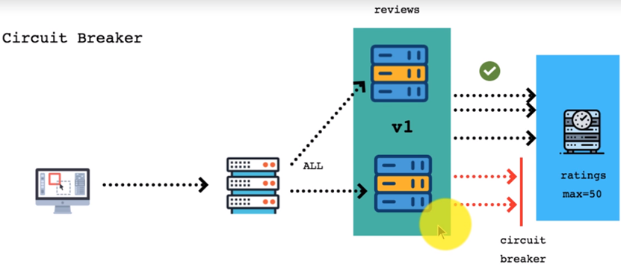

So what it is going to avoid is overload for the ratings application here and increase. Reduce the overall latency it won't let it increase the latency, because of that overload. Let's begin with this in our configuration. So first thing that I do is deploy this httpbin application and I had already deployed it and it is idempotent or if it already has the exact same configuration, it will not affect it at all. So it is safe to run that again.

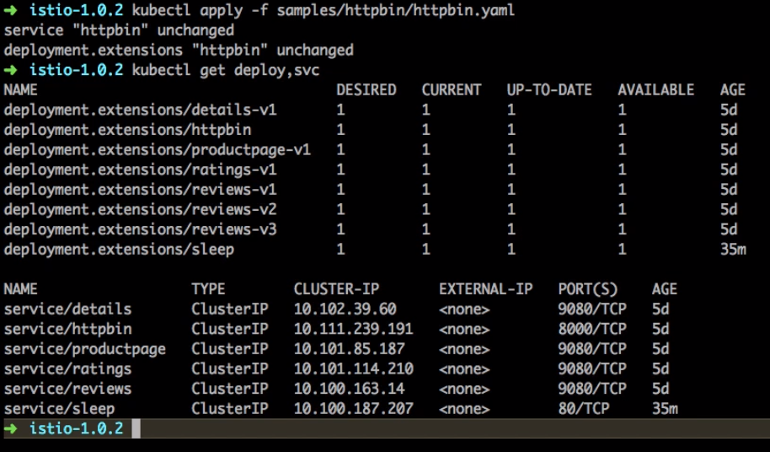

If I run get deploy, I see that httpbin deployment and the pods running for that, I already have the configuration for injecting the Proxy, injecting the proxy containers so I don't have to use that.

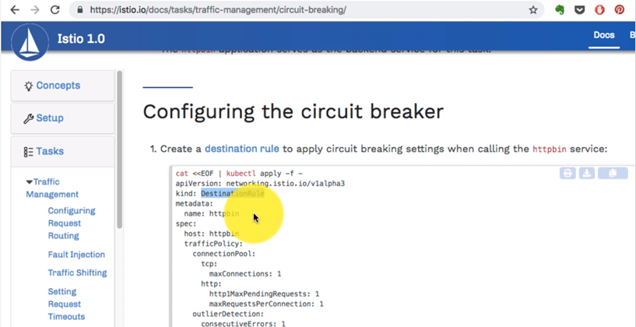

Now I'm going to use istioctl to and get information about my existing destination rules and what services because that is where you configure these configurations for the circuit breaker. So if I look at the destination rules right now, the httpbin has one here and I can get information about it by running get destination rule httpbin -o yaml.

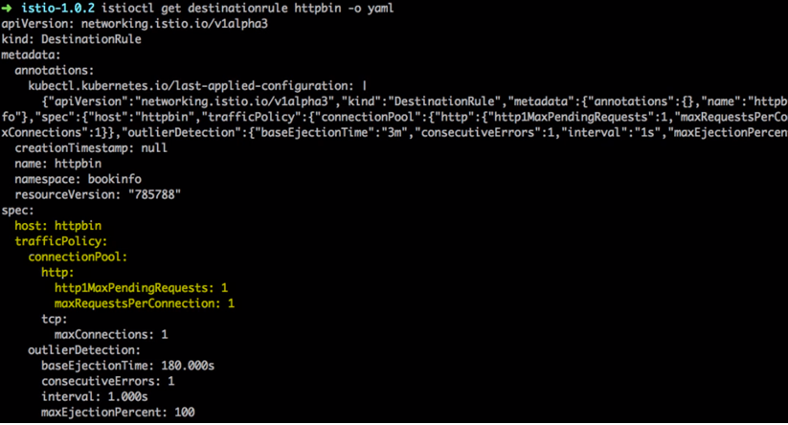

Now here, I see the configuration for circuit breaker. It's in the form of traffic policy and in the traffic policy you have policies for two – HTTP as well as TCP, so the max connections that I have defined is one. So my circuit breaker trips at a very restrictive thing but you know I'm just simulating how this works, so I have set it to one realistically, you'll have probably a few hundred connections as max connections for your application depending on the capacity. But if you want to trip it quickly. So we have that as the configuration, to a very very low threshold.

And this is the Destination rules.

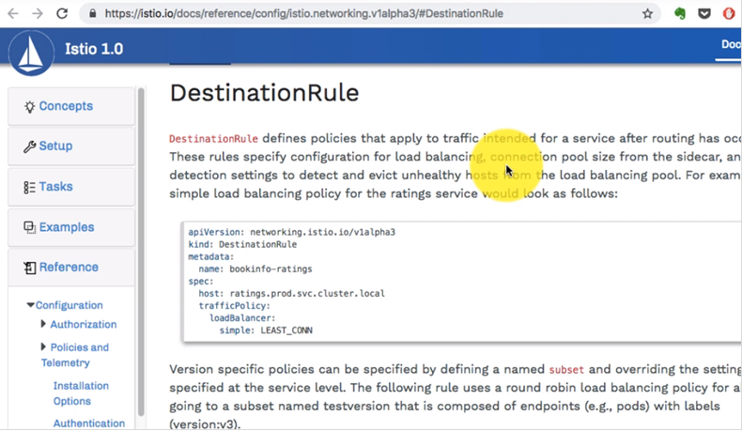

This is where we define the load balancer configuration as well as traffic policies, we are not defining load balance configuration but we are defining the traffic policies here - mainly the max connection pool.

Configuring the circuit breaker

Create a [destination rule](https://istio.io/docs/reference/config/istio.networking.v1alpha3/#DestinationRule) to apply circuit breaking settings when calling the httpbin service:

cat <<EOF | kubectl apply -f -

apiVersion: networking.istio.io/v1alpha3

kind: DestinationRule

metadata:

name: httpbin

spec:

host: httpbin

trafficPolicy:

connectionPool:

tcp:

maxConnections: 1

http:

http1MaxPendingRequests: 1

maxRequestsPerConnection: 1

outlierDetection:

consecutiveErrors: 1

interval: 1s

baseEjectionTime: 3m

maxEjectionPercent: 100

EOF

Verify the destination rule was created correctly:

$ kubectl get destinationrule httpbin -o yaml

*apiVersion: networking.istio.io/v1alpha3*

*kind: DestinationRule*

*metadata:*

*name: httpbin*

*...*

*spec:*

*host: httpbin*

*trafficPolicy:*

*connectionPool:*

*http:*

*http1MaxPendingRequests: 1*

*maxRequestsPerConnection: 1*

*tcp:*

*maxConnections: 1*

*outlierDetection:*

*baseEjectionTime: 180.000s*

*consecutiveErrors: 1*

*interval: 1.000s*

*maxEjectionPercent: 100*

That's where we have defined the maximum connections that are supported for this particular application, after which it should just trip and trigger the circuit breaker. And if it has configuration for TCP as well as HTTP, if it is TCP all you have to provide is maximum connection. If it is as HTTP one connection can make multiple request in a streaming connection so you also have pending request as well as Max request per connection. Both have been set as one. And if it trips, if it triggers, if it has errors, the next configuration is that outlier detection which will eject the pods which have the problems basically, or which will eject the connections.

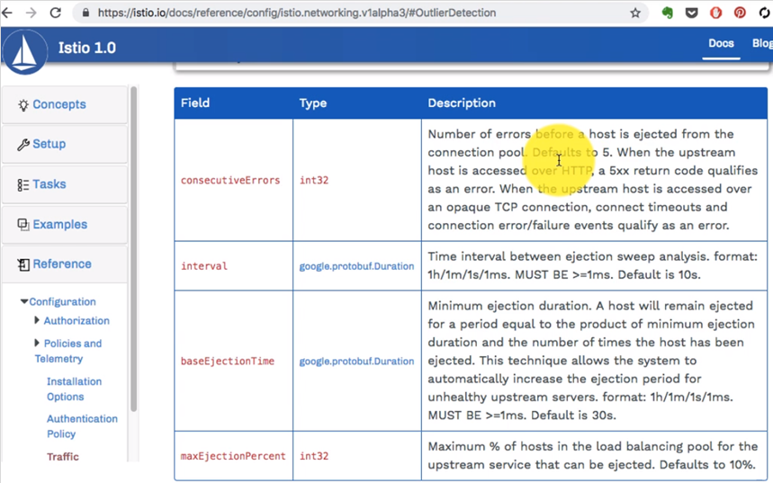

So this is where it gets tripped and then what action it takes and how much of those connections you stop or that's what you define here, for how long as the period is what you define here as well, so max rejection percentage - so you removed those many from the Lord balancer or if it has more than these many connections, since it gets removed from the load balancer, no more requests being sent to that for a particular amount of up for a particular period of time. That is how the circuit breaker of the work.

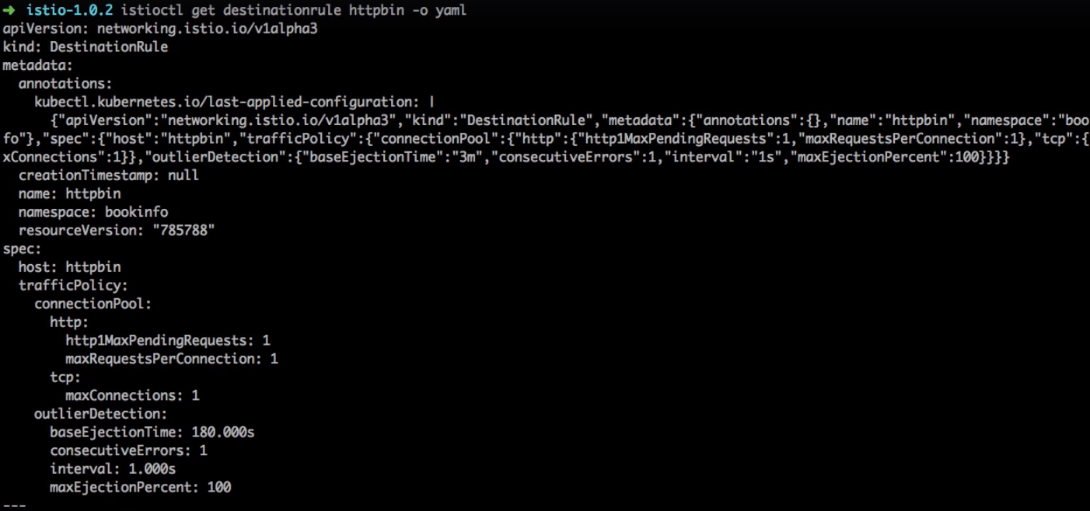

It would eject that pod from the Lord balancer, that's the configuration in the form of destination rule, circuit breaker configuration is that traffic policy where we have to defined connection pool outlier detection.

Now it's time to test it. So to test it I'm going to add a client and this time it has to be from inside the cluster. That's why I'm deploying it using this parallel command. I don't want to send the traffic from outside it has to be generated from inside. So this application called as fortio does just that. So I'm going to start an application pod with for you and it's all part of my sample.

Adding a client

Create a client to send traffic to the httpbin service. The client is a simple load-testing client called [fortio](https://github.com/istio/fortio). Fortio lets you control the number of connections, concurrency, and delays for outgoing HTTP calls. You will use this client to “trip” the circuit breaker policies you set in the DestinationRule.

Inject the client with the Istio sidecar proxy so network interactions are governed by Istio:

$ kubectl apply -f <(istioctl kube-inject -f [samples/httpbin/sample-client/fortio-deploy.yaml](https://raw.githubusercontent.com/istio/istio/release-1.0/samples/httpbin/sample-client/fortio-deploy.yaml))

Log in to the client pod and use the fortio tool to call httpbin. Pass in -curl to indicate that you just want to make one call:

$ FORTIO_POD=$(kubectl get pod | grep fortio | awk '{ print $1 }')

$ kubectl exec -it $FORTIO_POD -c fortio /usr/local/bin/fortio -- load -curl http://httpbin:8000/get

*HTTP/1.1 200 OK*

*server: envoy*

*date: Tue, 16 Jan 2018 23:47:00 GMT*

*content-type: application/json*

*access-control-allow-origin: \**

*access-control-allow-credentials: true*

*content-length: 445*

*x-envoy-upstream-service-time: 36*

*{*

*"args": {},*

*"headers": {*

*"Content-Length": "0",*

*"Host": "httpbin:8000",*

*"User-Agent": "istio/fortio-0.6.2",*

*"X-B3-Sampled": "1",*

*"X-B3-Spanid": "824fbd828d809bf4",*

*"X-B3-Traceid": "824fbd828d809bf4",*

*"X-Ot-Span-Context": "824fbd828d809bf4;824fbd828d809bf4;0000000000000000",*

*"X-Request-Id": "1ad2de20-806e-9622-949a-bd1d9735a3f4"*

*},*

*"origin": "127.0.0.1",*

*"url": "http://httpbin:8000/get"*

*}*

So samples/httpbin/sample-client and inside that I have this deployment, make sure you clean it up later after you're done trying out these exercises. So if I list the pods, I should see that in addition to that should it be been application that I already have. So I see that here.



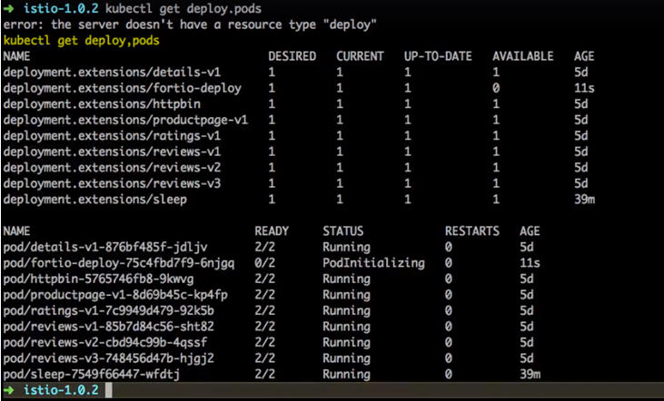

Now it's time to test it. So first thing that I do is get the pod detail for fortio.

You can see the request succeeded! Now, it’s time to break something.

And inside that I'm going to run an application or start a load test so that I start sending the request to this application. And with that you can either get fortio deployment pod name directly or you can use that command to set the environment variable. We're sending the request with just one client one request and it's trying to access httpbin colon 8000 and this goes through fine, because we're not tipping the number of connection, there is no threshold that we're reaching.

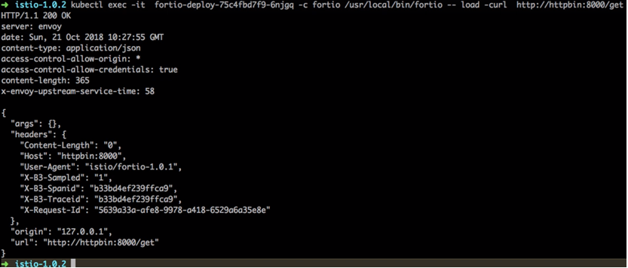

And if you observe, it sending the request to Envoy, not to the actual application but it goes via Envoy. Now it's time to trip the circuit breaker. This time I'm going to change that configuration and use 2 clients, do concurrent connections with 20 requests each. Let's find out what would happen, since I want to copy and paste. I will set that as a environment variable and it is available. And then just copy and paste to run that command so that it's relevant to concurrent connections.



And here's what happened.

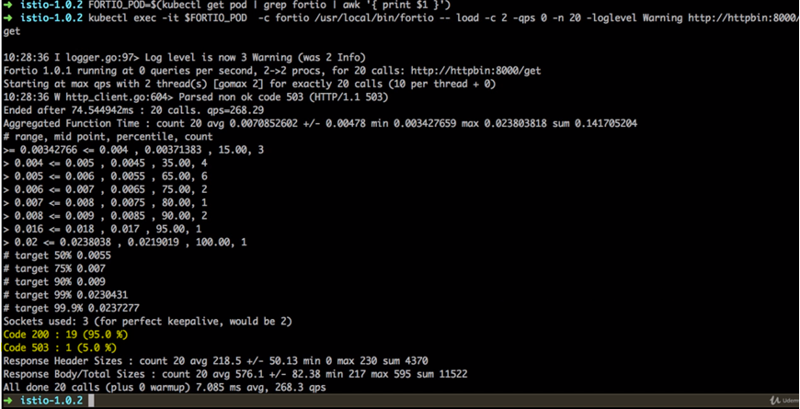

Now even if you have set one other threshold you'll still see most of these connections went through fine and you see the code 200 for 19 connections out of 20. So only 1% or 5% and one connection has tripped the circuit breaker because it always adds a little bit of a buffer and Istio proxy that's what it shows. So Istio proxy does allow for some leeway. Since we have very low configuration it looks like a lot of leeway. But even if you have hundreds of maximum connections it would allow you to have a little bit of leeway which is reasonable. Now if I increase the number of connection this time it has more connections which I've tripped.



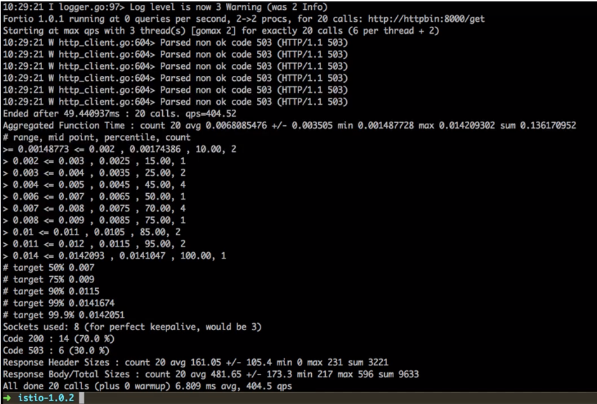

So six out of 20 - if I send request with 3 concurrent clients and again 20 each. So on an average it's tripping on. This time it's more so only 4 went through out of 20 and 16 have had an issue. So that's the circuit breaker in action. So what we've just achieved is a circuit breaking whereas if the threshold is crossed, with a little bit of a buffer, it would remove or stop responding so the now the onus is on the service which is calling the upstream service which will handle that error gracefully or send the traffic later on and keep on retrying and so on and so forth.

With a less number off request at any given point this would also avoid DdoS kind of attacks happening to your application. If there are too many requests being bombarded from one off the client's as well. So circuit breaker is a really useful thing to have and once you try this out you can always clean it up using this, so this also shows you the number of requests which crossed the circuit breaker in that overflow. So in our case, what I've seen is overflow has been flagged as both circuit breaker so that as basically those requests have been denied by circuit breaker request.

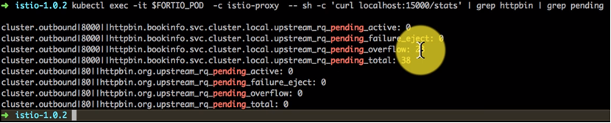

In my case so this is how the circuit breaker works in Istio, which is another useful feature which you can add to make your applications resilient. And now that I'm done with this I'm going to just clean it up by deleting the destination rules as well as the deployments for httpbin and the service configurations. It's always good to do that because if you look at the documentation for Istio, it's been written very well.

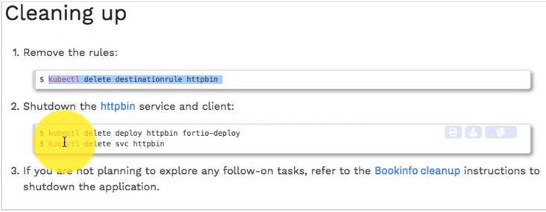

And before you start it will always tell you what do you launch first and then go ahead and you can always recreate the configurations at any point of time.

### Simulate real load in staging environments with Traffic Mirroring

Lets see how mirroring job works and this is a really really useful feature if you want to test your application with the live data and see if it actually works fine. So in this case v1 is the live data, 100 percent of traffic is going to it, what I have created and I want to start with the live. Typically when we do that we simulated some load. But in this case you can actually mirror the Load which means that all the production data is transparent to the user. So all the production data is also requests being sent to your v2, which will then be tested with the real life data which is just an amazing feature to have. And this works very well with Istio and that's what I'm going to show you, how to implement this feature. Now you can go to the document's tasks and if you go to scroll down to all the way to mirroring this is where it talks about how do you define how do you create it. Now before you begin you have to deploy the application. Now we want to try it out with two different versions of service, so you have to first create or deploy those two versions.

[LINK](https://istio.io/docs/tasks/traffic-management/mirroring/#before-you-begin)

**Before you begin**

Set up Istio by following the instructions in the [Installation guide](https://istio.io/docs/setup/).

Start by deploying two versions of the [httpbin](https://github.com/istio/istio/tree/release-1.0/samples/httpbin) service that have access logging enabled:

**httpbin-v1:**

cat <<EOF | istioctl kube-inject -f - | kubectl create -f -

apiVersion: extensions/v1beta1

kind: Deployment

metadata:

name: httpbin-v1

spec:

replicas: 1

template:

metadata:

labels:

app: httpbin

version: v1

spec:

containers:

- image: docker.io/kennethreitz/httpbin

imagePullPolicy: IfNotPresent

name: httpbin

command: ["gunicorn", "--access-logfile", "-", "-b", "0.0.0.0:8080", "httpbin:app"]

ports:

- containerPort: 8080

EOF

**httpbin-v2:**

cat <<EOF | istioctl kube-inject -f - | kubectl create -f -

apiVersion: extensions/v1beta1

kind: Deployment

metadata:

name: httpbin-v2

spec:

replicas: 1

template:

metadata:

labels:

app: httpbin

version: v2

spec:

containers:

- image: docker.io/kennethreitz/httpbin

imagePullPolicy: IfNotPresent

name: httpbin

command: ["gunicorn", "--access-logfile", "-", "-b", "0.0.0.0:8080", "httpbin:app"]

ports:

- containerPort: 8080

EOF

And I'm going to do that for one of the services here, that is the deployment for httpbin applications, so I'm going to deploy v1 and v2 as two different deployments. So first I create the v1 which is httpbin-v1. And then we create v2 as well. And here I see v1 being launched. I mean if you look at the configuration for v1 and we do it's the same but what we change is that the version that is the tag or the label and the name. So we just name it as v1 and v2. But we will always identify by looking at the pods and then checking the logs later. So this is for v2. So this is going to create a different deployment the deployment name this time is v2.

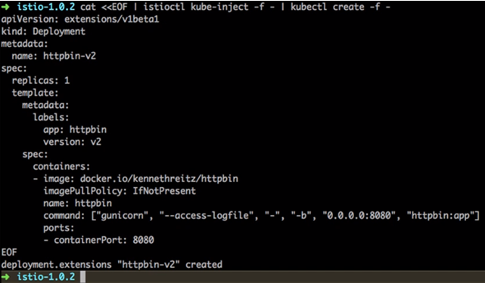

And it has 2 pods to send the traffic to. Next thing is we configured the service. This is the K8s service, Istio assumes that you have created a service with K8s, that is sort of a pre-requisite.

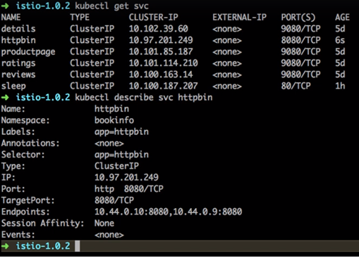

And that's what we are trying to fulfill here, by creating a service for httpbin. So if I use kubectl get svc, I see the service for httpbin and I can describe that using kubectl describe svc httpbin which shows me using the selector criteria that its httpbin, which version doesn't matter, so it has two end point which sent to two different pods.

Start the sleep service so you can use curl to provide load: [LINK](https://istio.io/docs/tasks/traffic-management/mirroring/)

**sleep service:**

cat <<EOF | istioctl kube-inject -f - | kubectl create -f -

apiVersion: extensions/v1beta1

kind: Deployment

metadata:

name: sleep

spec:

replicas: 1

template:

metadata:

labels:

app: sleep

spec:

containers:

- name: sleep

image: tutum/curl

command: ["/bin/sleep","infinity"]

imagePullPolicy: IfNotPresent

EOF

Next thing I am going to create the deployment call sleep which is already there. Now why do we create this deployment, is to send the traffic from, this is just a mock application, a mock pod running so that its running inside a Istio cluster, that is important so that we can send the traffic from that pod to our application. Now its time to define the routing policy, routing policies are defined as virtual services, routing policies are just routes versus definition rules – which are more like a load balancer configuration.

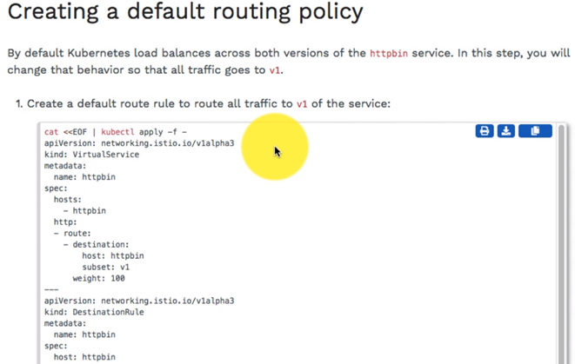

|  |  |
| --- | --- |
|  | What happens after it reaches that the route, reaches the httpbin, so it will send the traffic to either v1 or v2, but our route configuration says that use only v1 – we have defined the weightage as 100%. So it is going to send the traffic only to the v1, that is how we restrict, even though the load balancer has entry v1 and we define the weightage as 100 percent so that all the traffic a hundred percent of the traffic goes to only v1.  We have both what virtual service and destination rule configuration, let's observe the virtual service configuration again. So kubectl get virtualservice httpbin –o yaml, that shows me the route configuration as v1 with 100% weightage which is 100% traffic. |

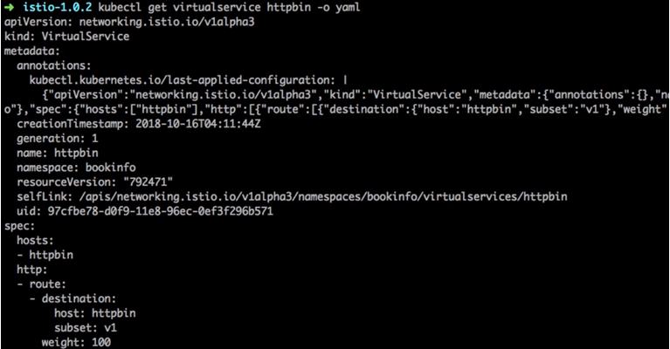

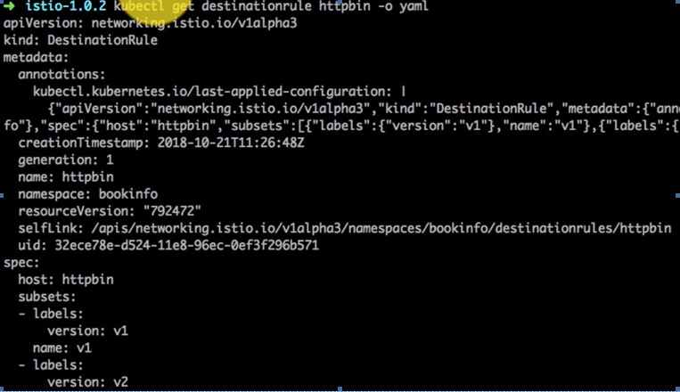

Then we can also displays destination rule ( kubectl get destinationrule httpbin –o yaml ) which is v1 and I'm OK with v1 and v2. Now you have to have this enabled in order for this to work because later on when we meet other traffic it has to know that it has an ability to send the traffic to v2 as well. Now its time to send the traffic. So I'm going to connect using exec to that pdo which I had created with the deployment called as sleep. From here, I'm going to send the traffic does what I did. Now I want to find out who this traffic is routed to whether it is v1 or v2.

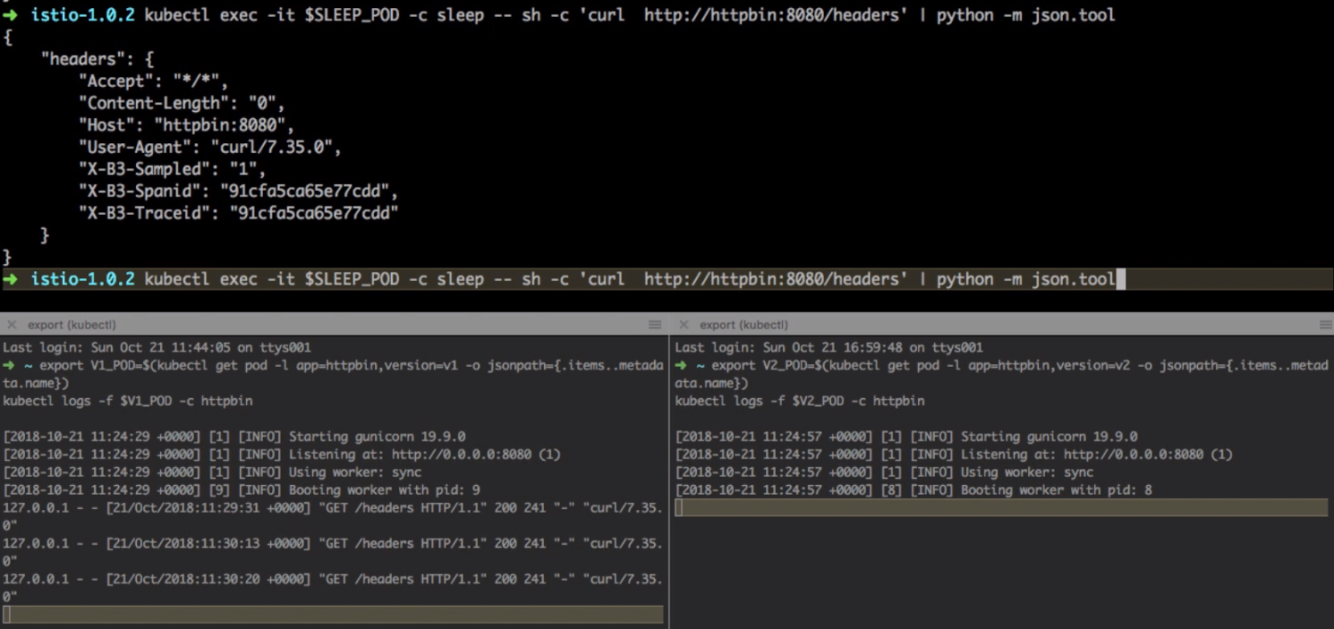

So no matter how many times I send a request it's all only going to V1. That's what we wanted to validate v2 receives no traffic whatsoever and that is part of our virtual service configuration. This time we're going to start mirroring the traffic to v2, let's assume that v2 is our staging environment and we want to try out that with actual production load and do the testing in staging as well. And for that mirroring is amazingly important here. So what I'm doing here is now, defining the traffic routing rules and you can always go to the configuration of traffic routing - virtual services. Here you'll find the specs. This is like K8s specs and in the deep route spec you will find the HTTP mirroring option.

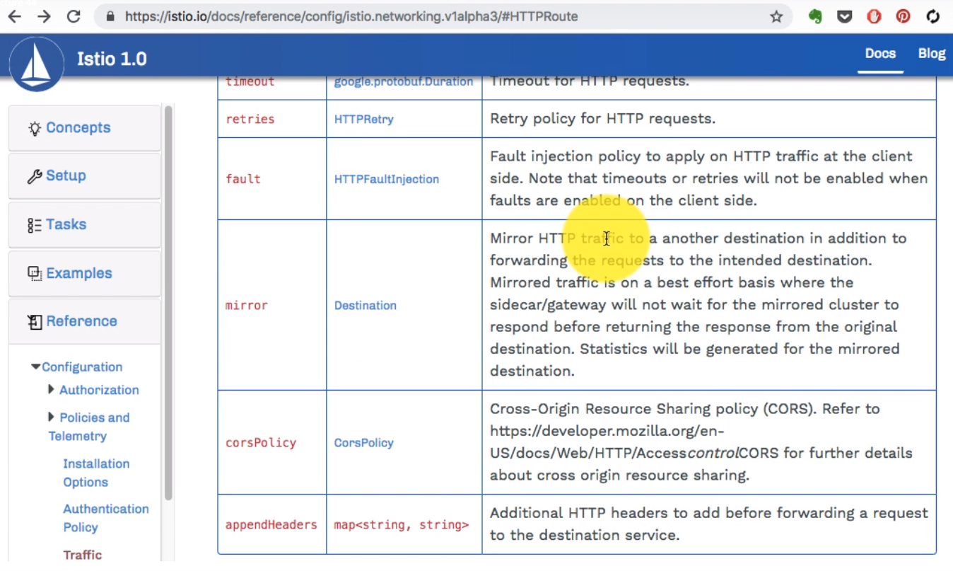

If you look at this it's similar to destination options. So it will have the host and subset and so on so it will be similar or just similar to the destinations as well. So this is how we're going to add the mirroring configuration which will only have host and the subset configuration just like our previous destination configuration for that route.

|  |
| --- |
| Mirroring traffic to v2  Change the route rule to mirror traffic to v2:  cat <<EOF | kubectl apply -f -  apiVersion: networking.istio.io/v1alpha3  kind: VirtualService  metadata:  name: httpbin  spec:  hosts:  - httpbin  http:  - route:  - destination:  host: httpbin  subset: v1  weight: 100  mirror:  host: httpbin  subset: v2  EOF  This route rule sends 100% of the traffic to v1. The last stanza specifies that you want to mirror to the httpbin v2 service. When traffic gets mirrored, the requests are sent to the mirrored service with their Host/Authority headers appended with -shadow. For example, cluster-1 becomes cluster-1-shadow.  Also, it is important to note that these requests are mirrored as “fire and forget”, which means that the responses are discarded.  Send in traffic:  $ kubectl exec -it $SLEEP_POD -c sleep -- sh -c 'curl http://httpbin:8080/headers' | python -m json.tool |

Let's start editing this object live using kubectl. I'm going to use kubectl to edit virtual service httpbin. So I can use kubectl to edit this now. You need to K8s it is before you come kubectl so make sure you have that foundation on k8s before you get started with this. So kubectl edit virtual service httpbin is what is going to open an editor and this is where I have that YAML configuration and there I see that route rules here, just below the route rules I'm going to add the mirror configuration.

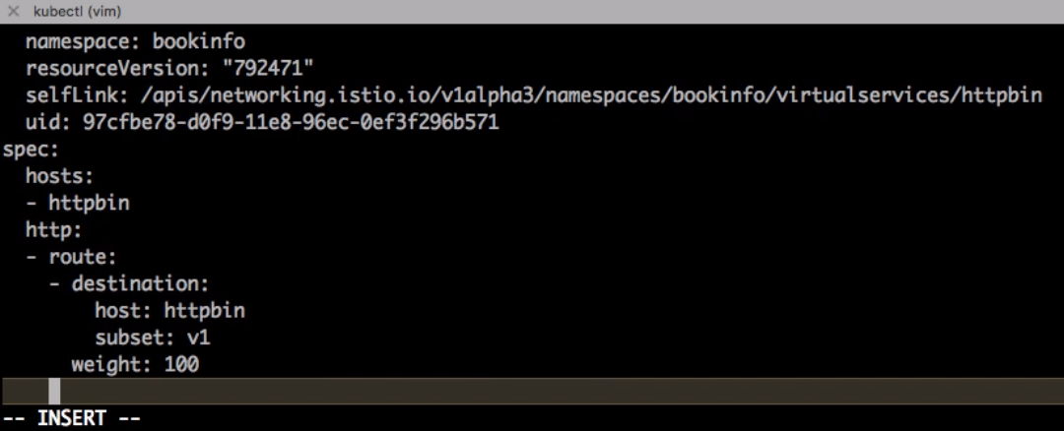

It's at the same level as the route and not at the destination. So I have to add that just below that destination, just below the route at the same level as route. It's very important indentation is extremely important with YAML. So make sure you do this correctly. So mirror host is httpbin and this is a similar configuration but V-2. So what we're doing is sending the traffic to v1 but also mirroring it to V-2 and this feature is my personal favorite feature from Istio actually. And this time if I try to send a request I see it reflected at both the places it's actually mirroring.

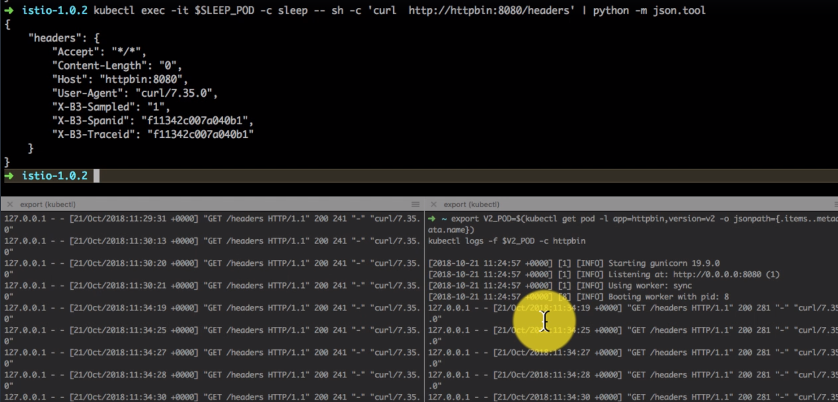

And this is amazingly useful if you want to try out your application the new version offered in a production like environment with the production like load. And that is just fantastic feature to have – Mirroring, and that is how it works. So it is a quick demo of how Mirroring works in Istio and it's time to clean up so I'm going to go ahead and delete the services and destination's that I had created along with the deployments and the services for httpbin

Cleaning up

Remove the rules:

$ kubectl delete virtualservice httpbin

$ kubectl delete destinationrule httpbin

Shutdown the httpbin service and client:

$ kubectl delete deploy httpbin-v1 httpbin-v2 sleep

$ kubectl delete svc httpbin

If you are not planning to explore any follow-on tasks, refer to the Bookinfo cleanup instructions to shutdown the application.

### Generating metrics and sending it to handlers

<https://istio.io/docs/tasks/telemetry/metrics-logs/>

In the section we're going to start talking about telemetry and let's have a look at what we're going to begin with. So if you go to the documents examples and have a look at telemetry, we're going to begin by collecting the data first by creating instances handlers and the rules. Once we do that we'll learn how to query that from prometheus. Then talk about distributed tracing using Jaggar and then look at the graph on our dashboards. We'll do some additional steps as well. So before we begin we already have this Istio cluster set up so that prerequisite has been taken care of.

In fact we have already installed Prometheus, Grafana and other adapters which are required in order for this to work. Now let's start collecting the Telemetry data. In this example we are going to collect two metrics - one is related to the request counts and second we are going to generate the count of requests. And second is we're going to generate the log for a service and that log will be how much time it's taking and latency and things like that. So the way it works is for the metrics that we're generating will be called as double request count. And what it generates is a value of 2 for every single request which it received. And then it is going to generate dimension, dimension is the schema that we are defining. That includes the reporter, the source, destination, messages and monitored resource type is going to be unspecified. And for every source so if the workload name is ( generally the pod application name ) if it is not defined it will use ‘unknown’ as the value and how this data the metric which will be generated - a set time series data and it will be sent and managed by Prometheus. That's where we are defining the handler here. The name of the handler is double handler and then metric name is double request count. That is what we are generating earlier and it is a type of data being handled is counter. And we also are defining the label names etc. So there'll be a match between the metric that we're generating i.e. the instance of data and the handler, in this case handler is Prometheus. How do you define that mapping is using the rule. So you need three things – instances, handlers and you need the rules - rules is where you're going to bind that instance with the particular handler or respective handler. In this case a Prometheus is a handler. Metric is the kind of data that we're generating. The second part of this is going to be about logs. So this is where we're defining the instance which is metric and it's going to collect some data related to that and put it in the Prometheus and then you can plot it with it Prometheus later.

|  |
| --- |
| Collecting new telemetry data  Create a new YAML file to hold configuration for the new metric and log stream that Istio will generate and collect automatically.  Save the following as new_telemetry.yaml:  **# Configuration for metric instances**  apiVersion: "config.istio.io/v1alpha2"  kind: metric  metadata:  name: doublerequestcount  namespace: istio-system  spec:  value: "2" # count each request twice  dimensions:  reporter: conditional((context.reporter.kind | "inbound") == "outbound", "client", "server")  source: source.workload.name | "unknown"  destination: destination.workload.name | "unknown"  message: '"twice the fun!"'  monitored_resource_type: '"UNSPECIFIED"'  ---  **# Configuration for a Prometheus handler**  apiVersion: "config.istio.io/v1alpha2"  kind: prometheus  metadata:  name: doublehandler  namespace: istio-system  spec:  metrics:  - name: double_request_count # Prometheus metric name  instance_name: doublerequestcount.metric.istio-system # Mixer instance name (fully-qualified)  kind: COUNTER  label_names:  - reporter  - source  - destination  - message  ---  **# Rule to send metric instances to a Prometheus handler**  apiVersion: "config.istio.io/v1alpha2"  kind: rule  metadata:  name: doubleprom  namespace: istio-system  spec:  actions:  - handler: doublehandler.prometheus  instances:  - doublerequestcount.metric  ---  **# Configuration for logentry instances**  apiVersion: "config.istio.io/v1alpha2"  kind: logentry  metadata:  name: newlog  namespace: istio-system  spec:  severity: '"warning"'  timestamp: request.time  variables:  source: source.labels["app"] | source.workload.name | "unknown"  user: source.user | "unknown"  destination: destination.labels["app"] | destination.workload.name | "unknown"  responseCode: response.code | 0  responseSize: response.size | 0  latency: response.duration | "0ms"  monitored_resource_type: '"UNSPECIFIED"'  ---  **# Configuration for a stdio handler**  apiVersion: "config.istio.io/v1alpha2"  kind: stdio  metadata:  name: newhandler  namespace: istio-system  spec:  severity_levels:  warning: 1 # Params.Level.WARNING  outputAsJson: **true**  ---  **# Rule to send logentry instances to a stdio handler**  apiVersion: "config.istio.io/v1alpha2"  kind: rule  metadata:  name: newlogstdio  namespace: istio-system  spec:  match: "true" # match for all requests  actions:  - handler: newhandler.stdio  instances:  - newlog.logentry  --- |

The second part is log entries so you're collecting the instance of kind log entry and this is where we are the name of the log. The severity is going to be mapped to the Log driver which is going to be warnings if we define the severity as warning - this data that we're generating as log is going to be a warning. And for every request how long it took - so what was the destination and what was the source, how much is the response time and that's going to be logged in to stand out, which would be a JSON file so it would be output as JSON. And again we have three three instance - One is the instance which is a log entry, the driver which is standard out as studio. And the rule is what maps it to the handlers to the instances. So this is the YAML file that we're going to create. So I copied that content and pasted it here and since it is just a YAML, I could just go ahead and apply it using kubectl apply -f <filename> which is new hypen underscore telemetry to YAML. This is going to create all these objects including the log entries and including the rules, log entries, prometheus the metrics and so on.

**Push the new configuration.**

$ kubectl apply -f new_telemetry.yaml

Created configuration metric/istio-system/doublerequestcount at revision 1973035

Created configuration prometheus/istio-system/doublehandler at revision 1973036

Created configuration rule/istio-system/doubleprom at revision 1973037

Created configuration logentry/istio-system/newlog at revision 1973038

Created configuration stdio/istio-system/newhandler at revision 1973039

Created configuration rule/istio-system/newlogstdio at revision 1973041

Send traffic to the sample application.

For the Bookinfo sample, visit http://$GATEWAY_URL/productpage in your web browser or issue the following command:

$ curl http://$GATEWAY_URL/productpage

Verify that the new metric values are being generated and collected.

In a Kubernetes environment, setup port-forwarding for Prometheus by executing the following command:

$ kubectl -n istio-system port-forward $(kubectl -n istio-system get pod -l app=prometheus -o jsonpath='{.items[0].metadata.name}') 9090:9090 &

You'll see all these objects being created. Most of these are CRDs or custom resource definitions as far as K8s is concerned. You can describe and list all these objects from the kubectl get metric. I don’t see any right now. That's probably because it's in some other namespace so if you don't find it in your own namespace you can use hyphen hyphen all name spaces.

$ kubectl get metric

No resources found

$ kubectl get metric --all-namespaces

NAMESPACES NAME AGE

Istio-system doublerequestcount 34s

Istio-system requestcount 5d

Istio-system requestduration 5d

Istio-system requestsize 5d

Istio-system responsesize 5d

Istio-system tcpbytereceived 5d

Istio-system tcpbytesent 5d

And in this case the namespace is Istio, it's part of this istiosystem - the requestcount, I see it there, that there's another one that's actually doublerequestcount, so that's the one I should be looking at. But you can list any one of this using kubectl get metrics and the name of that metric and then you have to provide the namespace for a specific namespace, In this case it's going to be is to be istiosystem and this is where you'll find how the data is being generated, and what is being collected and parsed and sliced and so on and so forth for the metric.

$ kubectl get metric requestcount –o yaml –n istiosystem

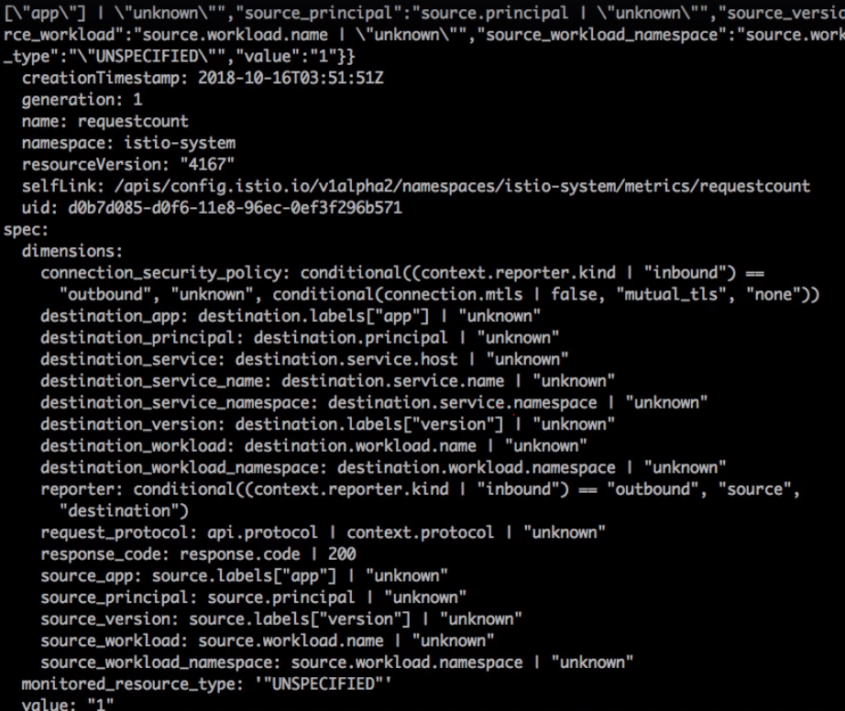

And that gets bound to other handlers that is Prometheus and you can list the details about that using the similar kind of commands using kubectl get and –o yaml. Now it's time to validate that it's actually generating this, so I'm going to look at two things - one is a Prometheus UI and 2nd is the logs. Let's look at Prometheus first and I need to start generating some data by providing some requests so I already have a chrome plugin which keeps on refreshing. It is really really useful plug to have. So I would highly recommend you install the refresh plugin to refresh plugin so that you can automatically send the request. And you will see the logs being generated as well. Next thing that I do is do the port mapping for Prometheus instance, so if you don't have the Prometheus or any of the services exposed outside either using Node Port or the Load Balancer, using this command which creates a secure tunnel from your localhost to that service.

$ kubectl -n istio-system port-forward $(kubectl -n istio-system get pod -l app=prometheus -o jsonpath='{.items[0].metadata.name}') 9090:9090 &

So in this case it is Prometheus and it actually the URL which was provided in the documentation also takes me to the Istio double request count, that's the metric that we are generating so data is there. And if you look at the format of the schema, it matches what it was added as part of that metric. And then you can plot for different time as well. So let's say five minutes, one hour, two hours and so on. So I've just selected five minutes and I see the request count for each of the services that I have including the book info application related services plus there are a few others for Istios internal services as well. If I keep running this for a long time I should see a lot of data and then I can then go and look at the results for the last few hours and that's what we're going to do.

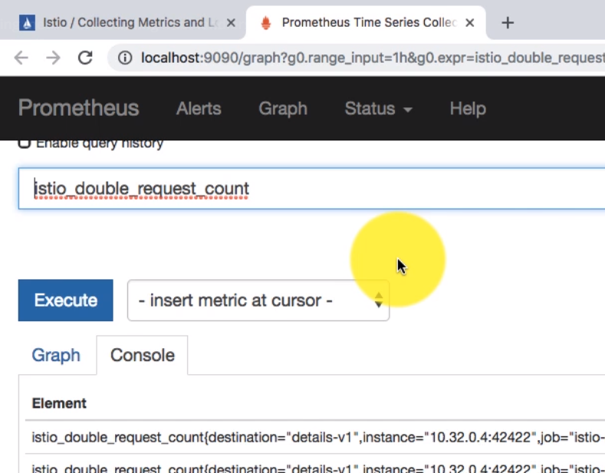

There we go, I have data that is plotted for the last five minutes. The next thing that I need to verify is that that for the second instance which was log entry which was handled by a stdio as the handler. And if I would have view that I would have to look for the logs for the pod which is collecting that, there is a mixer and I'm going to copy this command and paste it there so that I see what's happening.

So Istio mixture so this command actually is just slicing the output. Getting the right pod that you should be looking at and that's where the data it is being sent to. So that's the data. And if you look at observe the data it has all the fields that you had defined in that YAML when you created the instance of log entry which is all part of the istiosystem namespace and and I have just added change that logs to logs –f so that I can view this live.

Verify that the logs stream has been created and is being populated for requests.

In a Kubernetes environment, search through the logs for the istio-telemetry pod as follows:

$ kubectl -n istio-system logs $(kubectl -n istio-system get pods -l istio-mixer-type=telemetry -o jsonpath='{.items[0].metadata.name}') -c mixer | grep \"instance\":\"newlog.logentry.istio-system\"

*{"level":"warn","time":"2018-07-11T00:09:55.530274Z","instance":"newlog.logentry.istio-system","destination":"productpage","latency":"27.769937ms","responseCode":200,"responseSize":4415,"source":"istio-ingressgateway","user":"unknown"}*

*{"level":"warn","time":"2018-07-11T00:09:56.450852Z","instance":"newlog.logentry.istio-system","destination":"policy","latency":"566.375µs","responseCode":200,"responseSize":82,"source":"istio-ingressgateway","user":"unknown"}*

*{"level":"warn","time":"2018-07-11T00:09:56.458926Z","instance":"newlog.logentry.istio-system","destination":"reviews","latency":"4.940979ms","responseCode":200,"responseSize":295,"source":"productpage","user":"unknown"}*

*{"level":"warn","time":"2018-07-11T00:09:57.348865Z","instance":"newlog.logentry.istio-system","destination":"details","latency":"2.112762ms","responseCode":200,"responseSize":178,"source":"productpage","user":"unknown"}*

The chrome plugin is sending the request continuously and as soon as that data comes in, it is updating it right here, which gets logged for various services so that actually since it is a Microservices application, it gets calls for a lot of services, even for a single request. And that is where each of their service is being logged to. So you have three things instances, handlers and we have two types of instances, two types of handlers and each of that is being mapped to each other for instances that being mapped to handlers using the rules

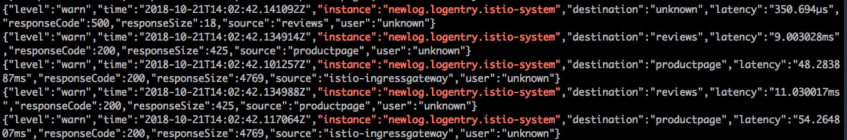

We've learned in this video how to create instances handlers and generate the metric or the log data which then can be handled by different handlers, in this case it was Prometheus one which plots the data. The second was the log entry which is just creating the logs and storing it in the istion system here. Those logs scan can then be forwarded to ELK stack tock and this document also talks about what is the configuration for the logs which fields were chosen and how do they map to the handler that is actually consuming that data. Later on we'll also configure to talk to Grafana and start plotting the graph that has been generated using Grafana. And this is where all the configuration is.

<https://istio.io/docs/tasks/telemetry/metrics-logs/>

### Querying Data with Prometheus

Lets now see how to query the metrics from Prometheus and slice that data and get exactly narrowed down to a specific service etc. Now before we get started, let's just validate that we have the prerequisite environment. We already have Prometheus running. And if you want to validate where the Promethues is is you can run kubectl get svc –n istiosystem and that should show you the instance of Promethues running, which is what I see here which is running on port 1990.

$ kubectl -n istio-system get svc prometheus

NAME CLUSTER-IP EXTERNAL-IP PORT(S) AGE

prometheus 10.59.241.54 <none> 9090/TCP 2m

Observed the port 1990 because when we do the port mapping we're going to use that port. You can also use get pods and that should show you the actual instance of Promethues running, so this was just sort of a load balancer and probably that part was actual instance running.

For the Bookinfo sample, visit http://$GATEWAY_URL/productpage in your web browser or issue the following command:

$ curl http://$GATEWAY_URL/productpage

$GATEWAY_URL is the value set in the [Bookinfo](https://istio.io/docs/examples/bookinfo/) example.

I have started you know refreshing this page using this refresh browser plugin and this is useful. I have the refresh time to four seconds. So now I have two browsers sending traffic to this cluster refreshing this product page every few minutes and that's useful because that will show them that will reflect in my on my priorities graphs as well. Now we have more instances of you know more instances of browser tabs running or generating more traffic. Now this is where I use kubctl port forward and the rest of the part is just finding out the pod name for Promethues. You can directly find out by the pod name and use that for forward and that would work as well.

Open the Prometheus UI.

In Kubernetes environments, execute the following command:

$ kubectl -n istio-system port-forward $(kubectl -n istio-system get pod -l app=prometheus -o jsonpath='{.items[0].metadata.name}') 9090:9090 &

Visit <http://localhost:9090/graph> in your web browser.

Execute a Prometheus query.

In the “Expression” input box at the top of the web page, enter the text: istio_requests_total. Then, click the **Execute** button.

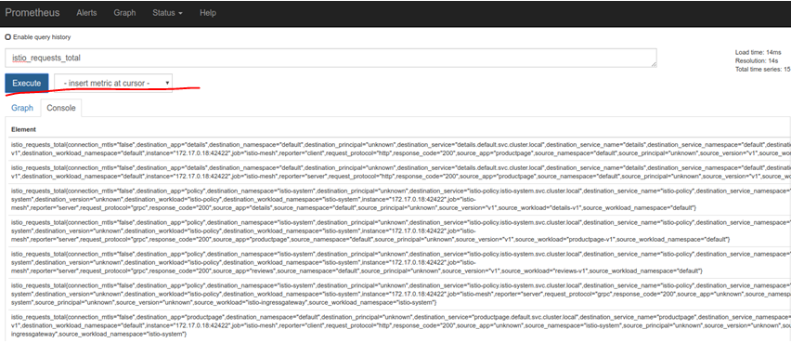

And here I have the Prometheus graphs and what I was looking at earlier was your istio request total. So total request counts. And this is generated by the metric that we had created earlier. And if I I showed you the data for five minutes but that's two less. So I've kept it running for a few minutes and then if I refresh it now I see some data for the last few hours. This is graph for last six hours. All the requests for each of the services. Now there are so many services as part of my book info application as well as istio system. So I see the graph for all the services right here. Now what I'm going to start doing is filtering this data by using the query and this supports its own query language, which is what I'm going to show you how to use that. And that also depends on the data that you have. So when you slice the data you would know your filter by some of these fields which are you know put in the console or the logs basically when the data was sent to Brument this this is how it was received and then it passed it and generated the graph based on that. Since we have all these fields we can query and narrow our results for a specific service or for particular the amount of time and things like that as well.

**Other queries to try:**

Total count of all requests to the productpage service:

istio_requests_total{destination_service="productpage.default.svc.cluster.local"}

Total count of all requests to v3 of the reviews service:

istio_requests_total{destination_service="reviews.default.svc.cluster.local", destination_version="v3"}

This query returns the current total count of all requests to the v3 of the reviews service.

Rate of requests over the past 5 minutes to all instances of the productpage service:

rate(istio_requests_total{destination_service=~"productpage.*", response_code="200"}[5m])

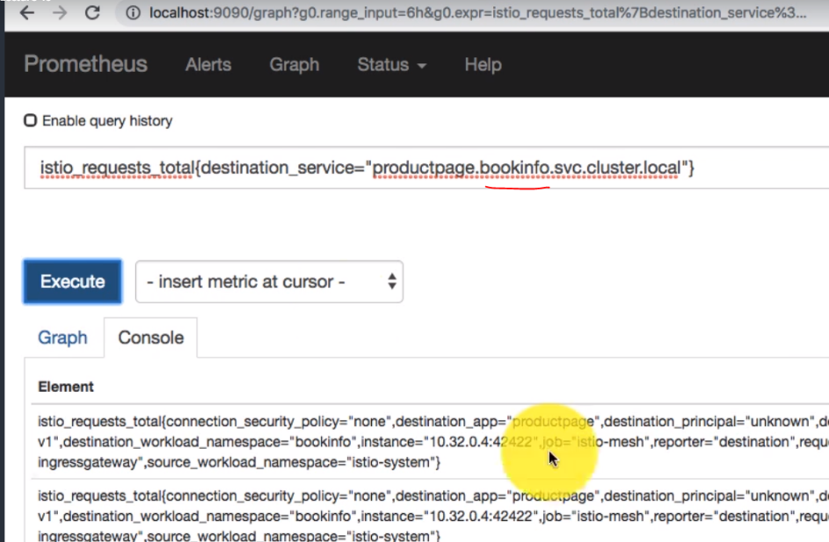

Please ensure that the namespace is the same else the query would not work

Listing the namespaces and the pods

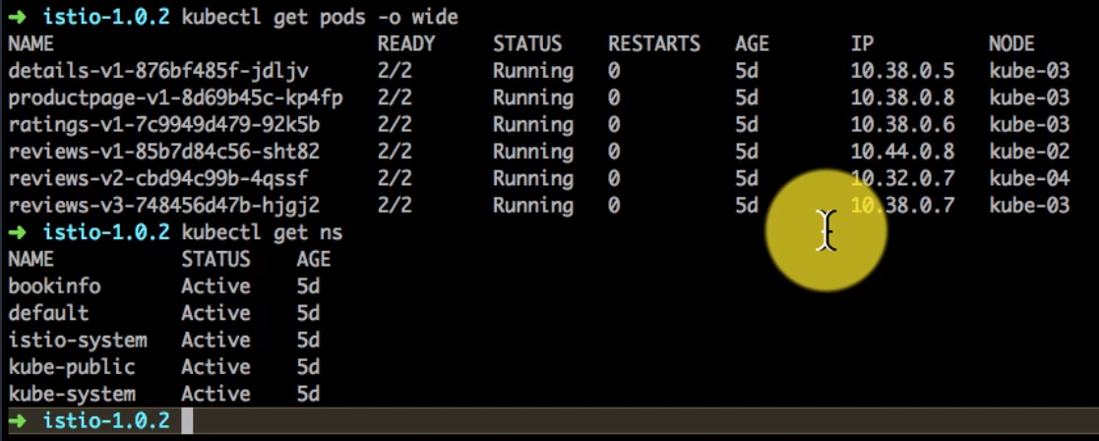

### Troubleshooting apps with distributed tracing with Jaeger

Distributed Tracing

This task shows you how Istio-enabled applications can be configured to collect trace spans. After completing this task, you should understand all of the assumptions about your application and how to have it participate in tracing, regardless of what language/framework/platform you use to build your application.

The [Bookinfo](https://istio.io/docs/examples/bookinfo/) sample is used as the example application for this task.

Before you begin

* Setup Istio by following the instructions in the [Installation guide](https://istio.io/docs/setup/).

Either use the istio-demo.yaml or istio-demo-auth.yaml template, which includes tracing support, or use the Helm chart with tracing enabled by setting the --set tracing.enabled=true option.

* Deploy the [Bookinfo](https://istio.io/docs/examples/bookinfo/) sample application.

Accessing the dashboard

Setup access to the Jaeger dashboard by using port-forwarding:

$ kubectl port-forward -n istio-system $(kubectl get pod -n istio-system -l app=jaeger -o jsonpath='{.items[0].metadata.name}') 16686:16686 &

Access the Jaeger dashboard by opening your browser to [http://localhost:16686](http://localhost:16686/).

Generating traces using the Bookinfo sample

With the Bookinfo application up and running, generate trace information by accessing http://$GATEWAY_URL/productpage one or more times.

From the left-hand pane of the Jaeger dashboard, select productpage from the Service drop-down list and click Find Traces. You should see something similar to the following:

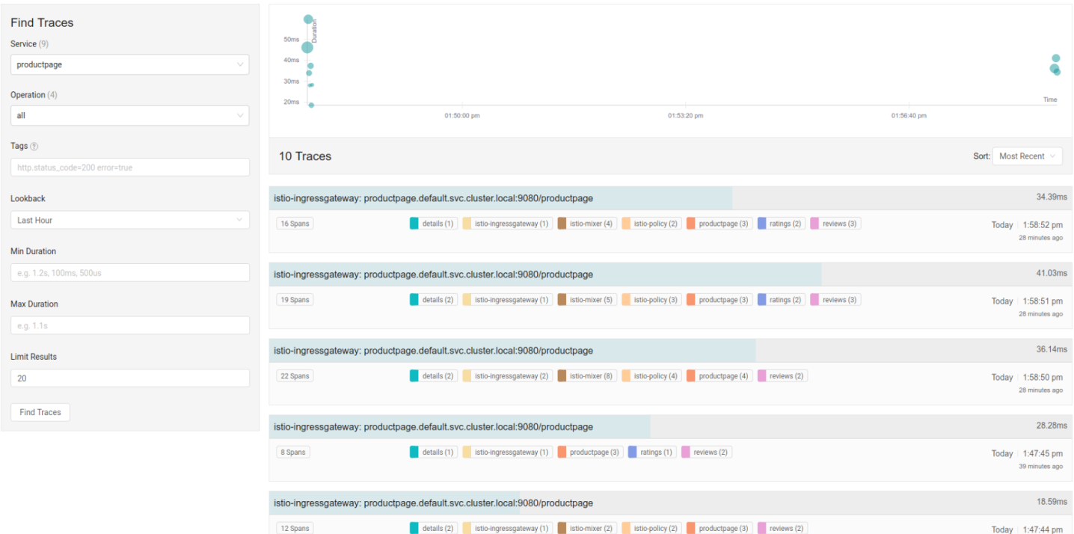

If you click on the top (most recent) trace, you should see the details corresponding to your latest refresh of the /productpage. The page should look something like this:

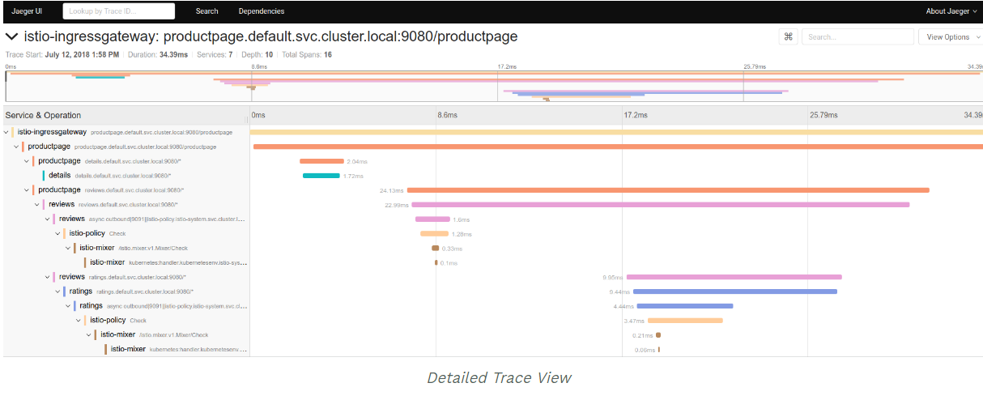

As you can see, the trace is comprised of a set of spans, where each span corresponds to a Bookinfo service invoked during the execution of a /productpagerequest.

Every RPC is represented by two spans in the trace. For example, the call from productpage to reviews starts with the span labeled productpage reviews.default.svc.cluster.local:9080/, which represents the client-side span for the call. It took 24.13ms . The second span (labeled reviews reviews.default.svc.cluster.local:9080/) is a child of the first span and represents the server-side span for the call. It took 22.99ms .

The trace for the call to the reviews services reveals two subsequent RPC’s in the trace. The first is to the istio-policy service, reflecting the server-side Check call made for the service to authorize access. The second is the call out to the ratings service.

Understanding what happened

Although Istio proxies are able to automatically send spans, they need some hints to tie together the entire trace. Applications need to propagate the appropriate HTTP headers so that when the proxies send span information, the spans can be correlated correctly into a single trace.

To do this, an application needs to collect and propagate the following headers from the incoming request to any outgoing requests:

x-request-id

x-b3-traceid

x-b3-spanid

x-b3-parentspanid

x-b3-sampled

x-b3-flags

x-ot-span-context

If you look in the sample services, you can see that the productpage service (Python) extracts the required headers from an HTTP request:

def getForwardHeaders(request):

headers = {}

if 'user' in session:

headers['end-user'] = session['user']

incoming_headers = [ 'x-request-id',

'x-b3-traceid',

'x-b3-spanid',

'x-b3-parentspanid',

'x-b3-sampled',

'x-b3-flags',

'x-ot-span-context'

]

for ihdr in incoming_headers:

val = request.headers.get(ihdr)

if val is not None:

headers[ihdr] = val

#print "incoming: "+ihdr+":"+val

return headers

The reviews application (Java) does something similar:

@GET

@Path("/reviews/{productId}")

public Response bookReviewsById(@PathParam("productId") int productId,

@HeaderParam("end-user") String user,

@HeaderParam("x-request-id") String xreq,

@HeaderParam("x-b3-traceid") String xtraceid,

@HeaderParam("x-b3-spanid") String xspanid,

@HeaderParam("x-b3-parentspanid") String xparentspanid,

@HeaderParam("x-b3-sampled") String xsampled,

@HeaderParam("x-b3-flags") String xflags,

@HeaderParam("x-ot-span-context") String xotspan) {

int starsReviewer1 = -1;

int starsReviewer2 = -1;

if (ratings_enabled) {

JsonObject ratingsResponse = getRatings(Integer.toString(productId), user, xreq, xtraceid, xspanid, xparentspanid, xsampled, xflags, xotspan);

When you make downstream calls in your applications, make sure to include these headers.

Trace sampling

Istio captures a trace for all requests by default. For example, when using the Bookinfo sample application above, every time you access /productpage you see a corresponding trace in the Jaeger dashboard. This sampling rate is suitable for a test or low traffic mesh. For a high traffic mesh you can lower the trace sampling percentage in one of two ways:

During the mesh setup, use the Helm option pilot.traceSampling to set the percentage of trace sampling. See the [Helm Install](https://istio.io/docs/setup/kubernetes/helm-install/) documentation for details on setting options.

In a running mesh, edit the istio-pilot deployment and change the environment variable with the following steps:

To open your text editor with the deployment configuration file loaded, run the following command:

$ kubectl -n istio-system edit deploy istio-pilot

Find the PILOT_TRACE_SAMPLING environment variable, and change the value: to your desired percentage.

In both cases, valid values are from 0.0 to 100.0 with a precision of 0.01.

Cleanup

Remove any kubectl port-forward processes that may still be running:

$ killall kubectl

If you are not planning to explore any follow-on tasks, refer to the [Bookinfo cleanup](https://istio.io/docs/examples/bookinfo/#cleanup) instructions to shutdown the application.

### Visualizing Metrics with Grafana

This task shows you how to setup and use the Istio Dashboard to monitor mesh traffic. As part of this task, you will install the Grafana Istio add-on and use the web-based interface for viewing service mesh traffic data.

The [Bookinfo](https://istio.io/docs/examples/bookinfo/) sample application is used as the example application throughout this task.

Before you begin

[Install Istio](https://istio.io/docs/setup/) in your cluster and deploy an application.

Viewing the Istio Dashboard

1. Verify that the prometheus service is running in your cluster.

In Kubernetes environments, execute the following command:

$ kubectl -n istio-system get svc prometheus

*NAME CLUSTER-IP EXTERNAL-IP PORT(S) AGE*

*prometheus 10.59.241.54 <none> 9090/TCP 2m*

1. Verify that the Grafana service is running in your cluster.

In Kubernetes environments, execute the following command:

$ kubectl -n istio-system get svc grafana

*NAME CLUSTER-IP EXTERNAL-IP PORT(S) AGE*

*grafana 10.59.247.103 <none> 3000/TCP 2m*

1. Open the Istio Dashboard via the Grafana UI.

In Kubernetes environments, execute the following command:

$ kubectl -n istio-system port-forward $(kubectl -n istio-system get pod -l app=grafana -o jsonpath='{.items[0].metadata.name}') 3000:3000 &

Visit <http://localhost:3000/dashboard/db/istio-mesh-dashboard> in your web browser.

The Istio Dashboard will look similar to:

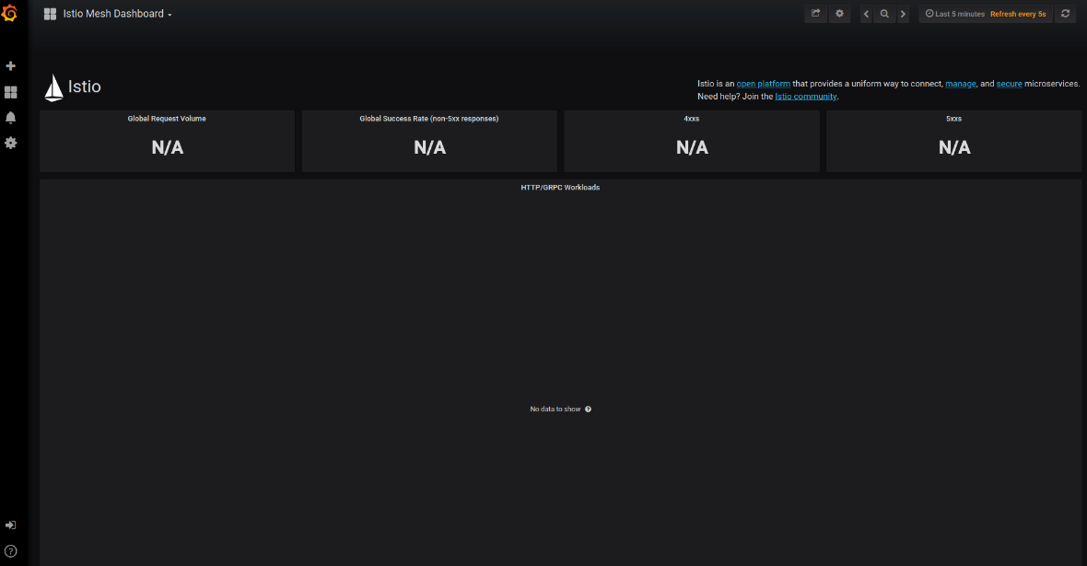

1. Send traffic to the mesh.

For the Bookinfo sample, visit http://$GATEWAY_URL/productpage in your web browser or issue the following command:

$ curl http://$GATEWAY_URL/productpage

Refresh the page a few times (or send the command a few times) to generate a small amount of traffic.

Look at the Istio Dashboard again. It should reflect the traffic that was generated. It will look similar to:

## MICROSERVICES

### 12 Factor Apps

**I. Codebase:** One codebase tracked in revision control, many deploys

**II. Dependencies:** Explicitly declare and isolate dependencies

**III. Config:** Store config in the environment

**IV. Backing services**: Treat backing services as attached resources

**V. Build, release, run**: Strictly separate build and run stages

**VI. Processes**: Execute the app as one or more stateless processes

**VII. Port binding**: Export services via port binding

**VIII. Concurrency**: Scale out via the process model

**IX. Disposability**: Maximize robustness with fast startup and graceful shutdown

**X. Dev/prod parity**: Keep development, staging, and production as similar as possible

**XI. Logs**: Treat logs as event streams

**XII. Admin processes**: Run admin/management tasks as one-off processes

**Codebase:**

One codebase tracked in revision control, many deploys. A twelve-factor app is always tracked in a version control system, such as Git, Mercurial, or Subversion. A copy of the revision tracking database is known as a code repository, often shortened to code repo or just repo. A codebase is any single repo (in a centralized revision control system like Subversion), or any set of repos who share a root commit (in a decentralized revision control system like Git).

One codebase maps to many deploys

|  |  |
| --- | --- |
|  | There is always a one-to-one correlation between the codebase and the app:  If there are multiple codebases, it’s not an app – it’s a distributed system. Each component in a distributed system is an app, and each can individually comply with twelve-factor. Multiple apps sharing the same code is a violation of twelve-factor. The solution here is to factor shared code into libraries which can be included through the dependency manager. There is only one codebase per app, but there will be many deploys of the app. A deploy is a running instance of the app. This is typically a production site, and one or more staging sites. Additionally, every developer has a copy of the app running in their local development environment, each of which also qualifies as a deploy. |

The codebase is the same across all deploys, although different versions may be active in each deploy. For example, a developer has some commits not yet deployed to staging; staging has some commits not yet deployed to production. But they all share the same codebase, thus making them identifiable as different deploys of the same app.

**II. Dependencies: Explicitly declare and isolate dependencies**

Most programming languages offer a packaging system for distributing support libraries, such as CPAN for Perl or Rubygems for Ruby. Libraries installed through a packaging system can be installed system-wide (known as “site packages”) or scoped into the directory containing the app (known as “vendoring” or “bundling”).

A twelve-factor app never relies on implicit existence of system-wide packages. It declares all dependencies, completely and exactly, via a dependency declaration manifest. Furthermore, it uses a dependency isolation tool during execution to ensure that no implicit dependencies “leak in” from the surrounding system. The full and explicit dependency specification is applied uniformly to both production and development.

For example, Bundler for Ruby offers the Gemfile manifest format for dependency declaration and bundle exec for dependency isolation. In Python there are two separate tools for these steps – Pip is used for declaration and Virtualenv for isolation. Even C has Autoconf for dependency declaration, and static linking can provide dependency isolation. No matter what the toolchain, dependency declaration and isolation must always be used together – only one or the other is not sufficient to satisfy twelve-factor.

One benefit of explicit dependency declaration is that it simplifies setup for developers new to the app. The new developer can check out the app’s codebase onto their development machine, requiring only the language runtime and dependency manager installed as prerequisites. They will be able to set up everything needed to run the app’s code with a deterministic build command. For example, the build command for Ruby/Bundler is bundle install, while for Clojure/Leiningen it is lein deps.

Twelve-factor apps also do not rely on the implicit existence of any system tools. Examples include shelling out to ImageMagick or curl. While these tools may exist on many or even most systems, there is no guarantee that they will exist on all systems where the app may run in the future, or whether the version found on a future system will be compatible with the app. If the app needs to shell out to a system tool, that tool should be vendored into the app.

**III. Config: Store config in the environment**

An app’s config is everything that is likely to vary between deploys (staging, production, developer environments, etc). This includes:

* Resource handles to the database, Memcached, and other backing services
* Credentials to external services such as Amazon S3 or Twitter
* Per-deploy values such as the canonical hostname for the deploy

Apps sometimes store config as constants in the code. This is a violation of twelve-factor, which requires strict separation of config from code. Config varies substantially across deploys, code does not.

A litmus test for whether an app has all config correctly factored out of the code is whether the codebase could be made open source at any moment, without compromising any credentials.

Note that this definition of “config” does not include internal application config, such as config/routes.rb in Rails, or how code modules are connected in Spring. This type of config does not vary between deploys, and so is best done in the code.

Another approach to config is the use of config files which are not checked into revision control, such as config/database.yml in Rails. This is a huge improvement over using constants which are checked into the code repo, but still has weaknesses: it’s easy to mistakenly check in a config file to the repo; there is a tendency for config files to be scattered about in different places and different formats, making it hard to see and manage all the config in one place. Further, these formats tend to be language- or framework-specific.

The twelve-factor app stores config in environment variables (often shortened to env vars or env). Env vars are easy to change between deploys without changing any code; unlike config files, there is little chance of them being checked into the code repo accidentally; and unlike custom config files, or other config mechanisms such as Java System Properties, they are a language- and OS-agnostic standard.

Another aspect of config management is grouping. Sometimes apps batch config into named groups (often called “environments”) named after specific deploys, such as the development, test, and production environments in Rails. This method does not scale cleanly: as more deploys of the app are created, new environment names are necessary, such as staging or qa. As the project grows further, developers may add their own special environments like joes-staging, resulting in a combinatorial explosion of config which makes managing deploys of the app very brittle.

In a twelve-factor app, env vars are granular controls, each fully orthogonal to other env vars. They are never grouped together as “environments”, but instead are independently managed for each deploy. This is a model that scales up smoothly as the app naturally expands into more deploys over its lifetime.

**IV. Backing services: Treat backing services as attached resources**

A backing service is any service the app consumes over the network as part of its normal operation. Examples include datastores (such as MySQL or CouchDB), messaging/queueing systems (such as RabbitMQ or Beanstalkd), SMTP services for outbound email (such as Postfix), and caching systems (such as Memcached).

Backing services like the database are traditionally managed by the same systems administrators as the app’s runtime deploy. In addition to these locally-managed services, the app may also have services provided and managed by third parties. Examples include SMTP services (such as Postmark), metrics-gathering services (such as New Relic or Loggly), binary asset services (such as Amazon S3), and even API-accessible consumer services (such as Twitter, Google Maps, or Last.fm).

The code for a twelve-factor app makes no distinction between local and third party services. To the app, both are attached resources, accessed via a URL or other locator/credentials stored in the config. A deploy of the twelve-factor app should be able to swap out a local MySQL database with one managed by a third party (such as Amazon RDS) without any changes to the app’s code. Likewise, a local SMTP server could be swapped with a third-party SMTP service (such as Postmark) without code changes. In both cases, only the resource handle in the config needs to change.

Each distinct backing service is a resource. For example, a MySQL database is a resource; two MySQL databases (used for sharding at the application layer) qualify as two distinct resources. The twelve-factor app treats these databases as attached resources, which indicates their loose coupling to the deploy they are attached to.

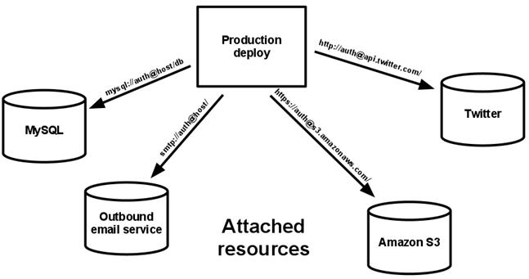

Resources can be attached to and detached from deploys at will. For example, if the app’s database is misbehaving due to a hardware issue, the app’s administrator might spin up a new database server restored from a recent backup. The current production database could be detached, and the new database attached – all without any code changes.

**V. Build, release, run: Strictly separate build and run stages**

A codebase is transformed into a (non-development) deploy through three stages:

The build stage is a transform which converts a code repo into an executable bundle known as a build. Using a version of the code at a commit specified by the deployment process, the build stage fetches vendors dependencies and compiles binaries and assets.

The release stage takes the build produced by the build stage and combines it with the deploy’s current config. The resulting release contains both the build and the config and is ready for immediate execution in the execution environment.

The run stage (also known as “runtime”) runs the app in the execution environment, by launching some set of the app’s processes against a selected release.

Code becomes a build, which is combined with config to create a release.

The twelve-factor app uses strict separation between the build, release, and run stages. For example, it is impossible to make changes to the code at runtime, since there is no way to propagate those changes back to the build stage.

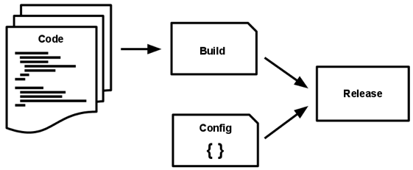

Deployment tools typically offer release management tools, most notably the ability to roll back to a previous release. For example, the Capistrano deployment tool stores releases in a subdirectory named releases, where the current release is a symlink to the current release directory. Its rollback command makes it easy to quickly roll back to a previous release.

Every release should always have a unique release ID, such as a timestamp of the release (such as 2011-04-06-20:32:17) or an incrementing number (such as v100). Releases are an append-only ledger and a release cannot be mutated once it is created. Any change must create a new release.

Builds are initiated by the app’s developers whenever new code is deployed. Runtime execution, by contrast, can happen automatically in cases such as a server reboot, or a crashed process being restarted by the process manager. Therefore, the run stage should be kept to as few moving parts as possible, since problems that prevent an app from running can cause it to break in the middle of the night when no developers are on hand. The build stage can be more complex, since errors are always in the foreground for a developer who is driving the deploy.

**VI. Processes: Execute the app as one or more stateless processes**

The app is executed in the execution environment as one or more processes.

In the simplest case, the code is a stand-alone script, the execution environment is a developer’s local laptop with an installed language runtime, and the process is launched via the command line (for example, python my_script.py). On the other end of the spectrum, a production deploy of a sophisticated app may use many process types, instantiated into zero or more running processes.

Twelve-factor processes are stateless and share-nothing. Any data that needs to persist must be stored in a stateful backing service, typically a database.

The memory space or filesystem of the process can be used as a brief, single-transaction cache. For example, downloading a large file, operating on it, and storing the results of the operation in the database. The twelve-factor app never assumes that anything cached in memory or on disk will be available on a future request or job – with many processes of each type running, chances are high that a future request will be served by a different process. Even when running only one process, a restart (triggered by code deploy, config change, or the execution environment relocating the process to a different physical location) will usually wipe out all local (e.g., memory and filesystem) state.

Asset packagers like django-assetpackager use the filesystem as a cache for compiled assets. A twelve-factor app prefers to do this compiling during the build stage. Asset packagers such as Jammit and the Rails asset pipeline can be configured to package assets during the build stage.

Some web systems rely on “sticky sessions” – that is, caching user session data in memory of the app’s process and expecting future requests from the same visitor to be routed to the same process. Sticky sessions are a violation of twelve-factor and should never be used or relied upon. Session state data is a good candidate for a datastore that offers time-expiration, such as Memcached or Redis.

**VII. Port binding: Export services via port binding**

Web apps are sometimes executed inside a webserver container. For example, PHP apps might run as a module inside Apache HTTPD, or Java apps might run inside Tomcat.

The twelve-factor app is completely self-contained and does not rely on runtime injection of a webserver into the execution environment to create a web-facing service. The web app exports HTTP as a service by binding to a port, and listening to requests coming in on that port.

In a local development environment, the developer visits a service URL like http://localhost:5000/ to access the service exported by their app. In deployment, a routing layer handles routing requests from a public-facing hostname to the port-bound web processes.

This is typically implemented by using dependency declaration to add a webserver library to the app, such as Tornado for Python, Thin for Ruby, or Jetty for Java and other JVM-based languages. This happens entirely in user space, that is, within the app’s code. The contract with the execution environment is binding to a port to serve requests.

HTTP is not the only service that can be exported by port binding. Nearly any kind of server software can be run via a process binding to a port and awaiting incoming requests. Examples include ejabberd (speaking XMPP), and Redis (speaking the Redis protocol).

Note also that the port-binding approach means that one app can become the backing service for another app, by providing the URL to the backing app as a resource handle in the config for the consuming app.

**VIII. Concurrency: Scale out via the process model**

Any computer program, once run, is represented by one or more processes. Web apps have taken a variety of process-execution forms. For example, PHP processes run as child processes of Apache, started on demand as needed by request volume. Java processes take the opposite approach, with the JVM providing one massive uberprocess that reserves a large block of system resources (CPU and memory) on startup, with concurrency managed internally via threads. In both cases, the running process(es) are only minimally visible to the developers of the app.

Scale is expressed as running processes, workload diversity is expressed as process types.

In the twelve-factor app, processes are a first class citizen. Processes in the twelve-factor app take strong cues from the unix process model for running service daemons. Using this model, the developer can architect their app to handle diverse workloads by assigning each type of work to a process type. For example, HTTP requests may be handled by a web process, and long-running background tasks handled by a worker process.

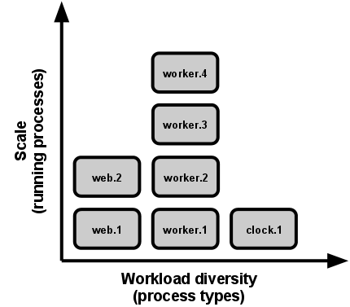

This does not exclude individual processes from handling their own internal multiplexing, via threads inside the runtime VM, or the async/evented model found in tools such as EventMachine, Twisted, or Node.js. But an individual VM can only grow so large (vertical scale), so the application must also be able to span multiple processes running on multiple physical machines.

The process model truly shines when it comes time to scale out. The share-nothing, horizontally partitionable nature of twelve-factor app processes means that adding more concurrency is a simple and reliable operation. The array of process types and number of processes of each type is known as the process formation.

Twelve-factor app processes should never daemonize or write PID files. Instead, rely on the operating system’s process manager (such as systemd, a distributed process manager on a cloud platform, or a tool like Foreman in development) to manage output streams, respond to crashed processes, and handle user-initiated restarts and shutdowns.

**IX. Disposability: Maximize robustness with fast startup and graceful shutdown**

The twelve-factor app’s processes are disposable, meaning they can be started or stopped at a moment’s notice. This facilitates fast elastic scaling, rapid deployment of code or config changes, and robustness of production deploys.

Processes should strive to minimize startup time. Ideally, a process takes a few seconds from the time the launch command is executed until the process is up and ready to receive requests or jobs. Short startup time provides more agility for the release process and scaling up; and it aids robustness, because the process manager can more easily move processes to new physical machines when warranted.

Processes shut down gracefully when they receive a SIGTERM signal from the process manager. For a web process, graceful shutdown is achieved by ceasing to listen on the service port (thereby refusing any new requests), allowing any current requests to finish, and then exiting. Implicit in this model is that HTTP requests are short (no more than a few seconds), or in the case of long polling, the client should seamlessly attempt to reconnect when the connection is lost.

For a worker process, graceful shutdown is achieved by returning the current job to the work queue. For example, on RabbitMQ the worker can send a NACK; on Beanstalkd, the job is returned to the queue automatically whenever a worker disconnects. Lock-based systems such as Delayed Job need to be sure to release their lock on the job record. Implicit in this model is that all jobs are reentrant, which typically is achieved by wrapping the results in a transaction, or making the operation idempotent.

Processes should also be robust against sudden death, in the case of a failure in the underlying hardware. While this is a much less common occurrence than a graceful shutdown with SIGTERM, it can still happen. A recommended approach is use of a robust queueing backend, such as Beanstalkd, that returns jobs to the queue when clients disconnect or time out. Either way, a twelve-factor app is architected to handle unexpected, non-graceful terminations. Crash-only design takes this concept to its logical conclusion.

**X. Dev/prod parity: Keep development, staging, and production as similar as possible**

Historically, there have been substantial gaps between development (a developer making live edits to a local deploy of the app) and production (a running deploy of the app accessed by end users). These gaps manifest in three areas:

* The time gap: A developer may work on code that takes days, weeks, or even months to go into production.
* The personnel gap: Developers write code, ops engineers deploy it.
* The tools gap: Developers may be using a stack like Nginx, SQLite, and OS X, while the production deploy uses Apache, MySQL, and Linux.

The twelve-factor app is designed for continuous deployment by keeping the gap between development and production small. Looking at the three gaps described above:

Make the time gap small: a developer may write code and have it deployed hours or even just minutes later.

Make the personnel gap small: developers who wrote code are closely involved in deploying it and watching its behavior in production.

Make the tools gap small: keep development and production as similar as possible.

Summarizing the above into a table:

**Traditional app Twelve-factor app**

Time between deploys Weeks Hours

Code authors vs code deployers Different people Same people

Dev vs production environments Divergent As similar as possible

Backing services, such as the app’s database, queueing system, or cache, is one area where dev/prod parity is important. Many languages offer libraries which simplify access to the backing service, including adapters to different types of services. Some examples are in the table below.

**Type Language Library Adapters**

Database Ruby/Rails ActiveRecord MySQL, PostgreSQL, SQLite

Queue Python/Django Celery RabbitMQ, Beanstalkd, Redis

Cache Ruby/Rails ActiveSupport::Cache Memory, filesystem, Memcached

Developers sometimes find great appeal in using a lightweight backing service in their local environments, while a more serious and robust backing service will be used in production. For example, using SQLite locally and PostgreSQL in production; or local process memory for caching in development and Memcached in production.

The twelve-factor developer resists the urge to use different backing services between development and production, even when adapters theoretically abstract away any differences in backing services. Differences between backing services mean that tiny incompatibilities crop up, causing code that worked and passed tests in development or staging to fail in production. These types of errors create friction that disincentivizes continuous deployment. The cost of this friction and the subsequent dampening of continuous deployment is extremely high when considered in aggregate over the lifetime of an application.

Lightweight local services are less compelling than they once were. Modern backing services such as Memcached, PostgreSQL, and RabbitMQ are not difficult to install and run thanks to modern packaging systems, such as Homebrew and apt-get. Alternatively, declarative provisioning tools such as Chef and Puppet combined with light-weight virtual environments such as Docker and Vagrant allow developers to run local environments which closely approximate production environments. The cost of installing and using these systems is low compared to the benefit of dev/prod parity and continuous deployment.

Adapters to different backing services are still useful, because they make porting to new backing services relatively painless. But all deploys of the app (developer environments, staging, production) should be using the same type and version of each of the backing services.

**XI. Logs: Treat logs as event streams**

Logs provide visibility into the behavior of a running app. In server-based environments they are commonly written to a file on disk (a “logfile”); but this is only an output format.

Logs are the stream of aggregated, time-ordered events collected from the output streams of all running processes and backing services. Logs in their raw form are typically a text format with one event per line (though backtraces from exceptions may span multiple lines). Logs have no fixed beginning or end, but flow continuously as long as the app is operating.

A twelve-factor app never concerns itself with routing or storage of its output stream. It should not attempt to write to or manage logfiles. Instead, each running process writes its event stream, unbuffered, to stdout. During local development, the developer will view this stream in the foreground of their terminal to observe the app’s behavior.

In staging or production deploys, each process’ stream will be captured by the execution environment, collated together with all other streams from the app, and routed to one or more final destinations for viewing and long-term archival. These archival destinations are not visible to or configurable by the app, and instead are completely managed by the execution environment. Open-source log routers (such as Logplex and Fluentd) are available for this purpose.

The event stream for an app can be routed to a file, or watched via realtime tail in a terminal. Most significantly, the stream can be sent to a log indexing and analysis system such as Splunk, or a general-purpose data warehousing system such as Hadoop/Hive. These systems allow for great power and flexibility for introspecting an app’s behavior over time, including:

* Finding specific events in the past.
* Large-scale graphing of trends (such as requests per minute).
* Active alerting according to user-defined heuristics (such as an alert when the quantity of errors per minute exceeds a certain threshold)

**XII. Admin processes: Run admin/management tasks as one-off processes**

The process formation is the array of processes that are used to do the app’s regular business (such as handling web requests) as it runs. Separately, developers will often wish to do one-off administrative or maintenance tasks for the app, such as:

Running database migrations (e.g. manage.py migrate in Django, rake db:migrate in Rails).

Running a console (also known as a REPL shell) to run arbitrary code or inspect the app’s models against the live database. Most languages provide a REPL by running the interpreter without any arguments (e.g. python or perl) or in some cases have a separate command (e.g. irb for Ruby, rails console for Rails).

Running one-time scripts committed into the app’s repo (e.g. php scripts/fix_bad_records.php).

One-off admin processes should be run in an identical environment as the regular long-running processes of the app. They run against a release, using the same codebase and config as any process run against that release. Admin code must ship with application code to avoid synchronization issues.

The same dependency isolation techniques should be used on all process types. For example, if the Ruby web process uses the command bundle exec thin start, then a database migration should use bundle exec rake db:migrate. Likewise, a Python program using Virtualenv should use the vendored bin/python for running both the Tornado webserver and any manage.py admin processes.

Twelve-factor strongly favors languages which provide a REPL shell out of the box, and which make it easy to run one-off scripts. In a local deploy, developers invoke one-off admin processes by a direct shell command inside the app’s checkout directory. In a production deploy, developers can use ssh or other remote command execution mechanism provided by that deploy’s execution environment to run such a process.

Also see

<https://learning.oreilly.com/videos/develop-and-operate/9781789135206?autoplay=false>

<https://www.udemy.com/docker-for-java-developers/learn/v4/t/lecture/6659194?start=15>

<https://learning.oreilly.com/learning-paths/learning-path-learning/9781789346442/>

### Principles of MicroServices

